Circular Path
# Source: AI Source: Provided by: [Data Path: Persons Table -> ID Column: 1, Name_En Column: Motasem Essam] -> From: [ChatGPT] on [7/25/2026]
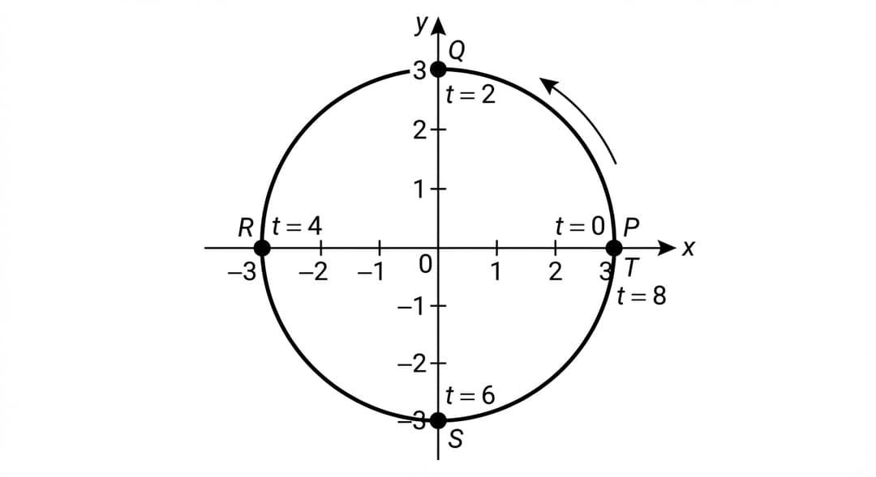
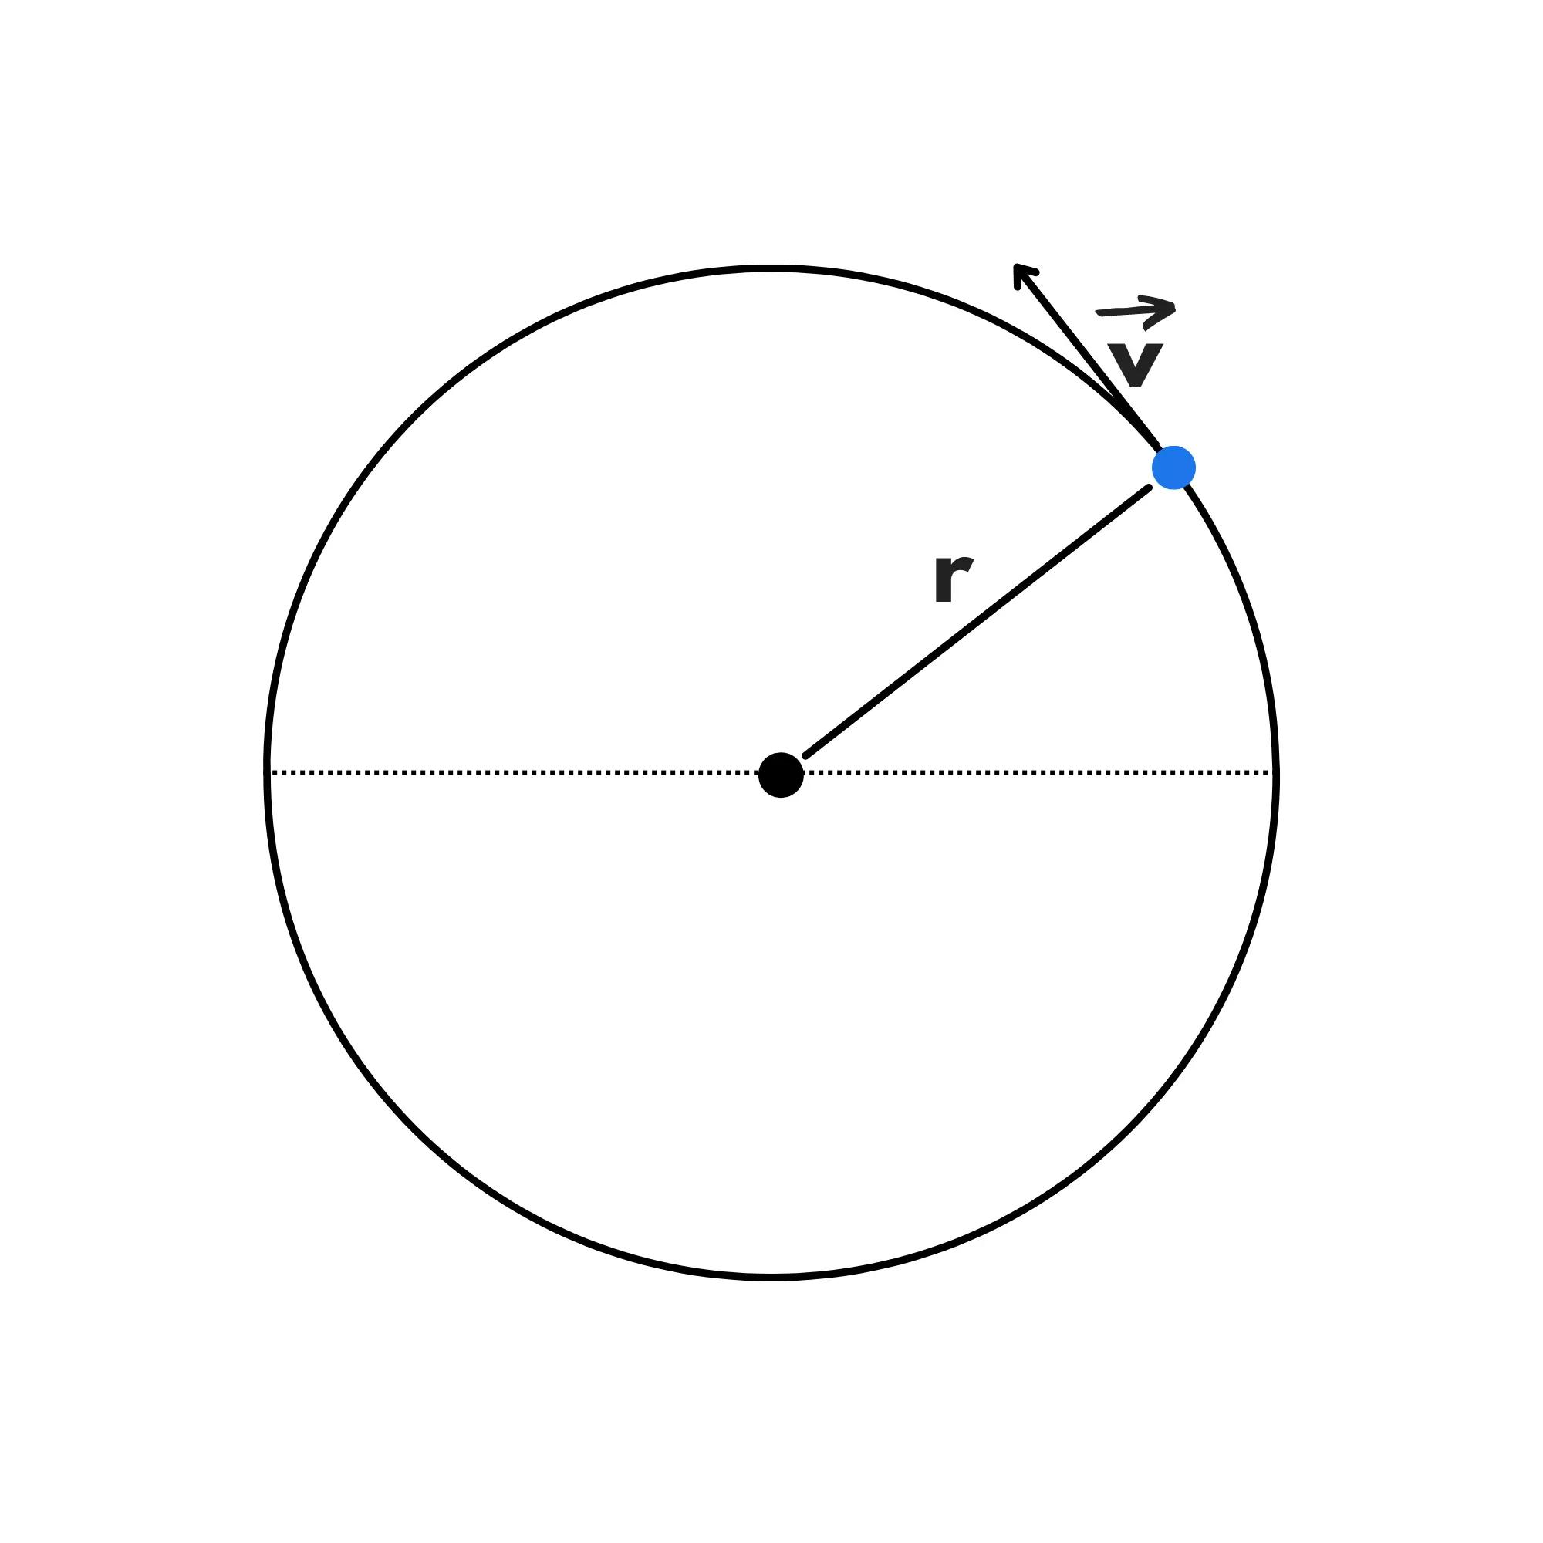
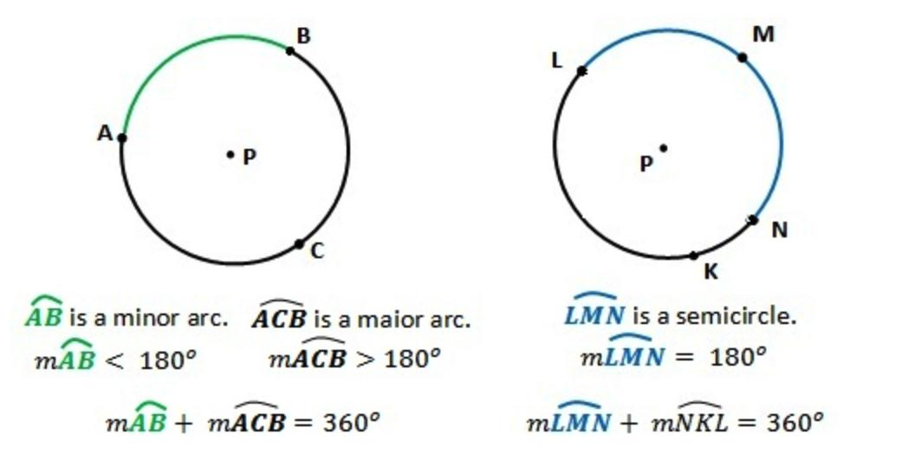
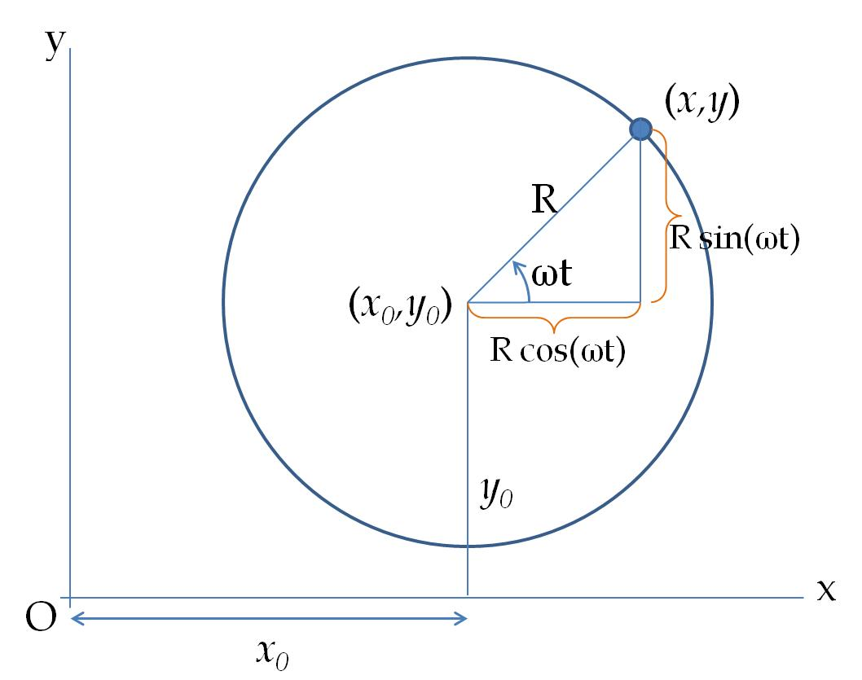
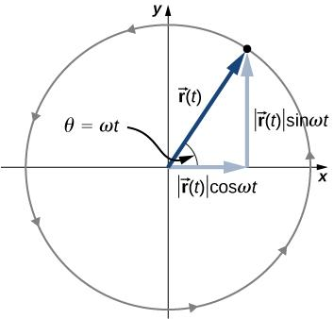

Definition
# Source: AI Source: Provided by: [Data Path: Persons Table -> ID Column: 1, Name_En Column: Motasem Essam] -> From: [ChatGPT] on [7/25/2026]
A Circular Path is a geometric path in which a moving point remains at a constant distance from a fixed point, called the center.
If $P$moves around a fixed center $O$with constant radius $r$, then:
$$\boxed{OP=r}$$
The set of all possible positions of $P$forms a circle.
Simple Definition
A Circular Path is the path traced by a point that moves around a fixed center while maintaining a constant distance from that center.

Basic Structure
# Source: AI Source: Provided by: [Data Path: Persons Table -> ID Column: 1, Name_En Column: Motasem Essam] -> From: [ChatGPT] on [7/25/2026]
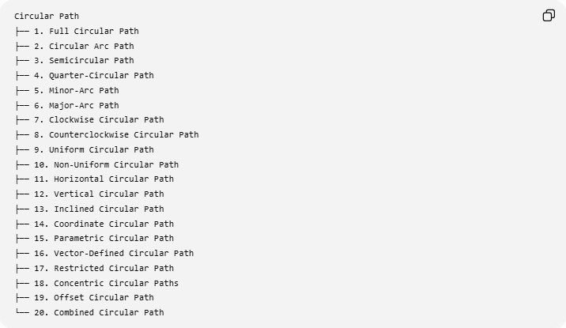
Circular Path
├── 1. Full Circular Path
├── 2. Circular Arc Path
├── 3. Semicircular Path
├── 4. Quarter-Circular Path
├── 5. Minor-Arc Path
├── 6. Major-Arc Path
├── 7. Clockwise Circular Path
├── 8. Counterclockwise Circular Path
├── 9. Uniform Circular Path
├── 10. Non-Uniform Circular Path
├── 11. Horizontal Circular Path
├── 12. Vertical Circular Path
├── 13. Inclined Circular Path
├── 14. Coordinate Circular Path
├── 15. Parametric Circular Path
├── 16. Vector-Defined Circular Path
├── 17. Restricted Circular Path
├── 18. Concentric Circular Paths
├── 19. Offset Circular Path
└── 20. Combined Circular Path

1. Full Circular Path
# Source: AI Source: Provided by: [Data Path: Persons Table -> ID Column: 1, Name_En Column: Motasem Essam] -> From: [ChatGPT] on [7/25/2026]
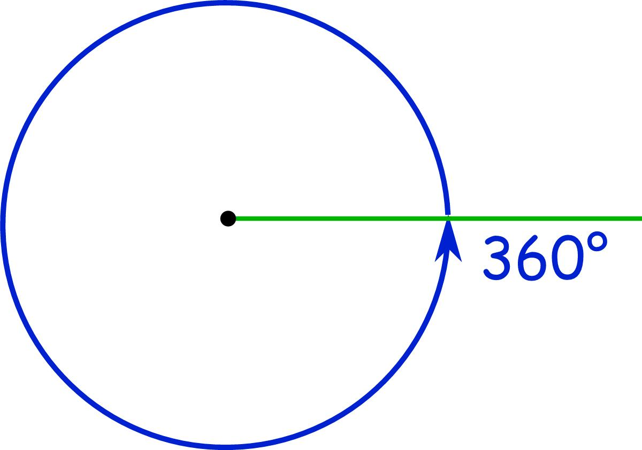
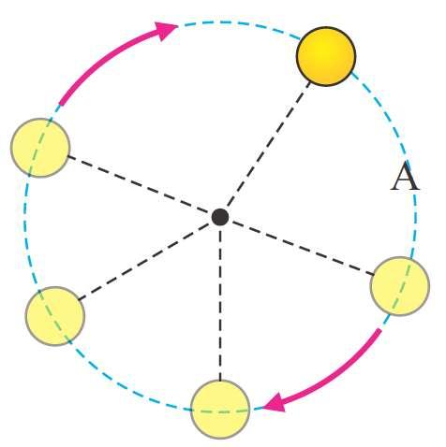
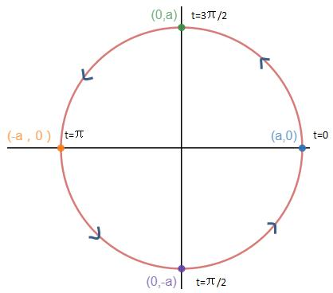
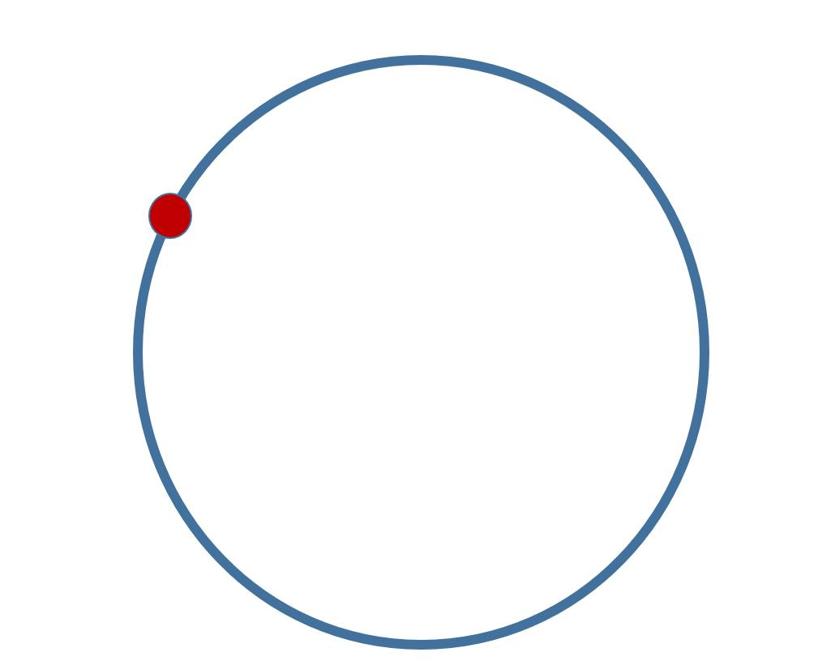
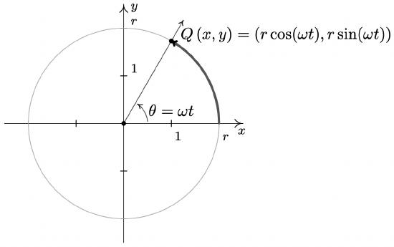
Definition
A Full Circular Path is a complete circular path in which a point travels through an entire ${360}^{∘}$around the center.
$$\boxed{θ={360}^{∘}=2π}$$
Example
If a point travels once around a circle of radius:
$$r=5,$$
the path length is the circumference:
$$C=2πr \\ \boxed{C=10π}$$

2. Circular Arc Path
# Source: AI Source: Provided by: [Data Path: Persons Table -> ID Column: 1, Name_En Column: Motasem Essam] -> From: [ChatGPT] on [7/25/2026]
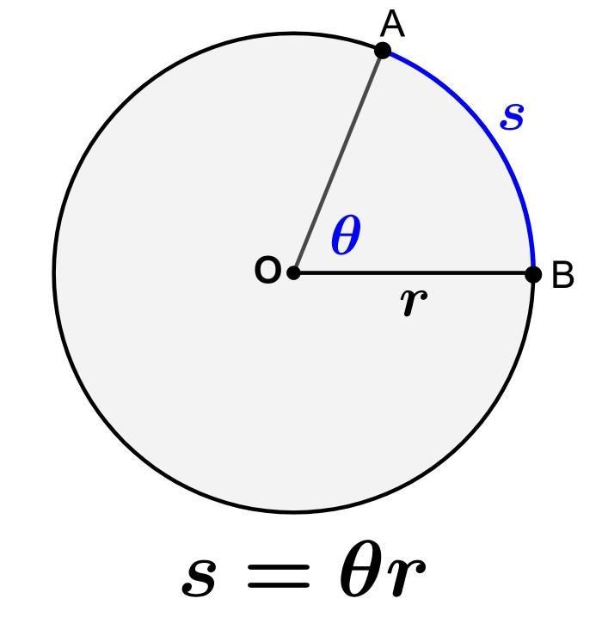
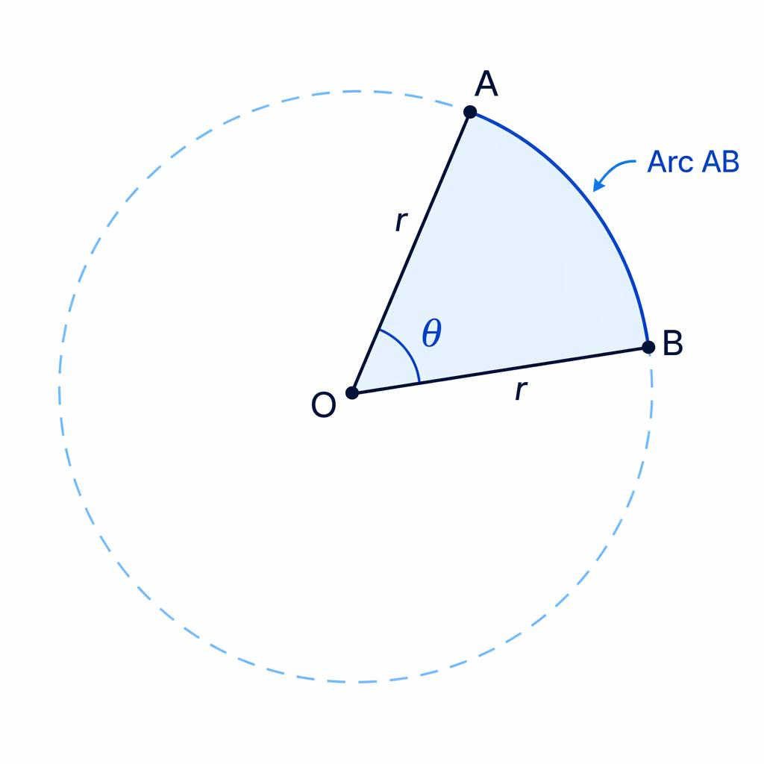
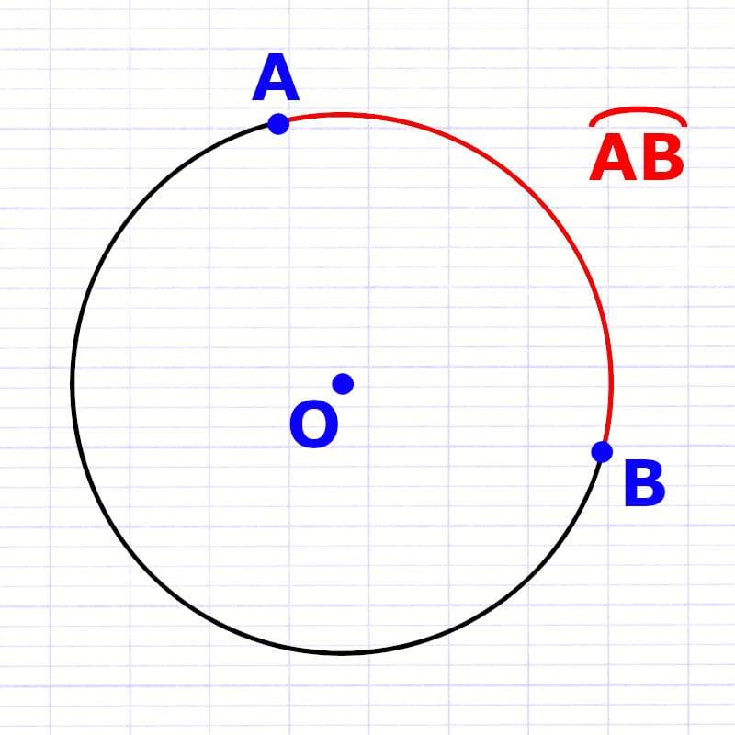
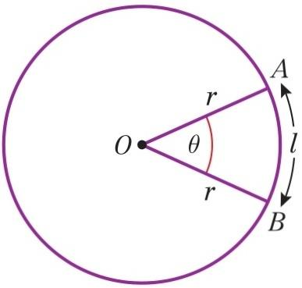
Definition
A Circular Arc Path is a portion of a circle between two points.
If $A$and $B$lie on a circle, the path from $A$to $B$along the circle is an arc.
Arc Length
For central angle $θ$measured in radians:
$$\boxed{s=rθ}$$
For degrees:
$$\boxed{s=\frac{θ}{{360}^{∘}}\left(2πr\right)}$$
Example
For:
$$r=6, θ={60}^{∘},$$
the arc length is:
$$s=\frac{60}{360}\left(2π\right)\left(6\right) \\ \boxed{s=2π}.$$

3. Semicircular Path
# Source: AI Source: Provided by: [Data Path: Persons Table -> ID Column: 1, Name_En Column: Motasem Essam] -> From: [ChatGPT] on [7/25/2026]
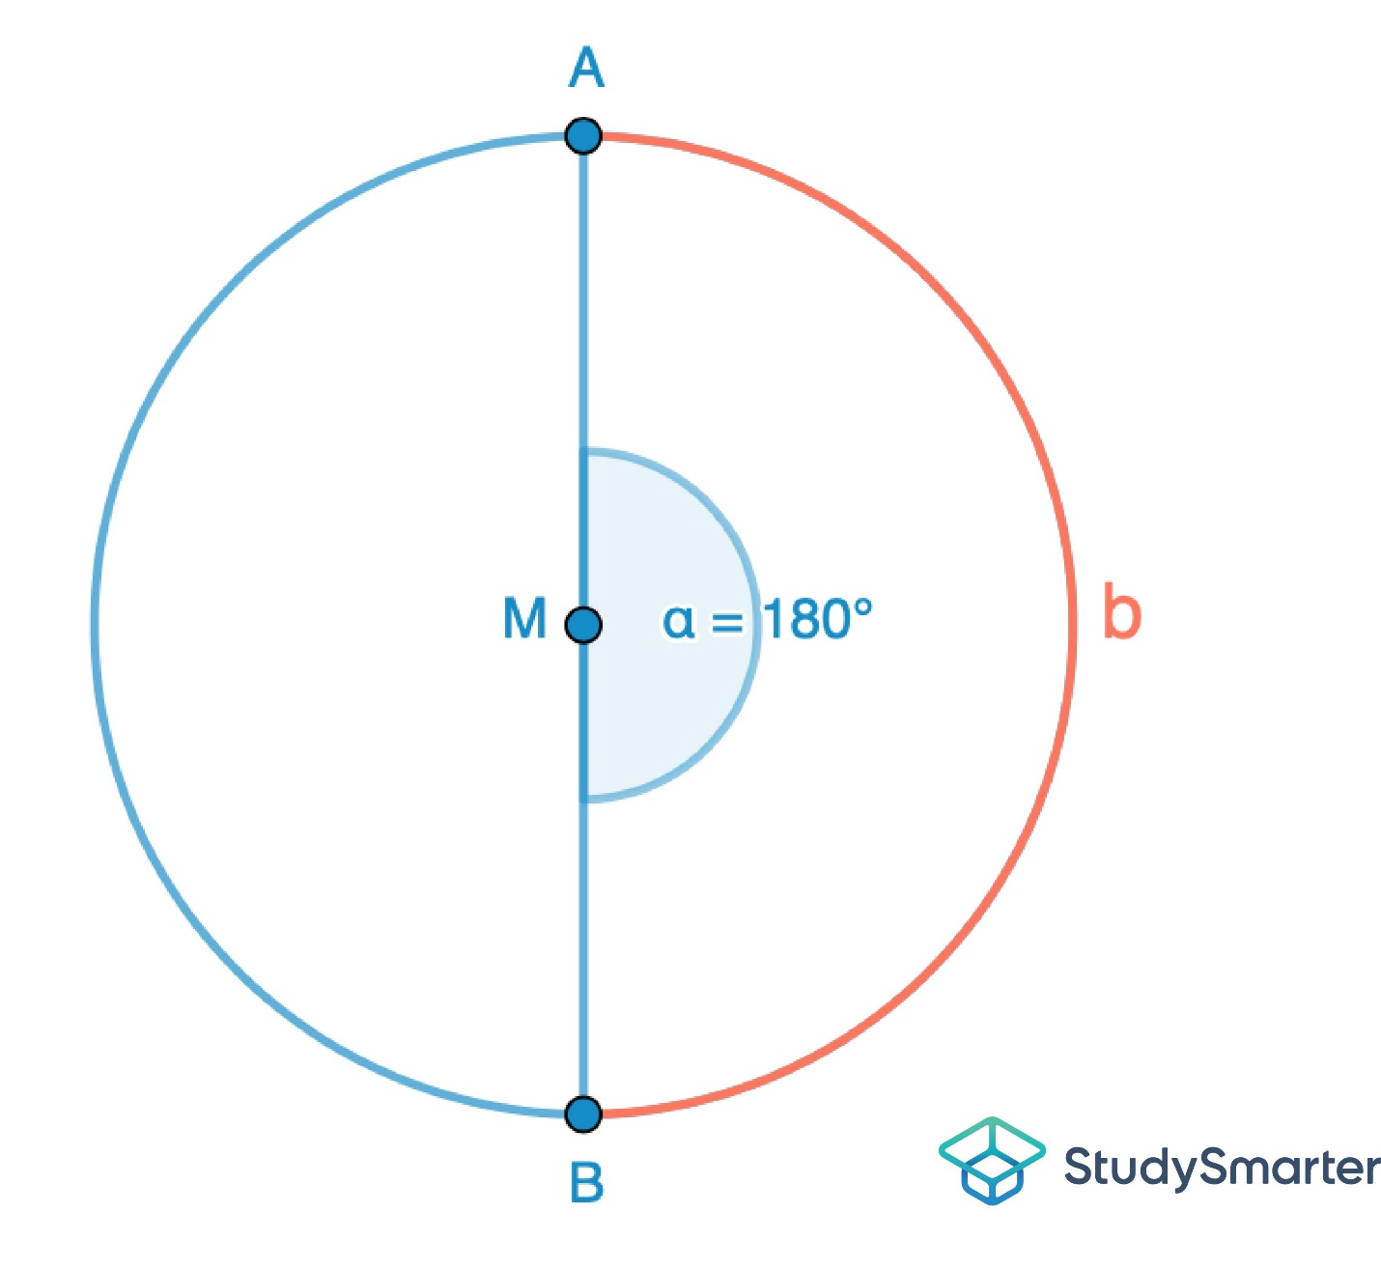
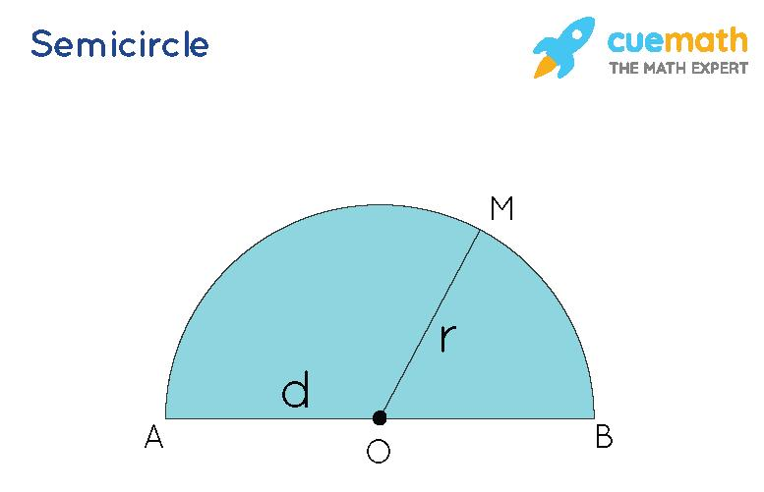
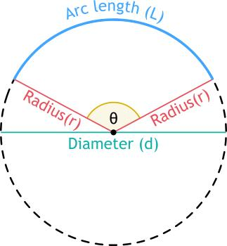
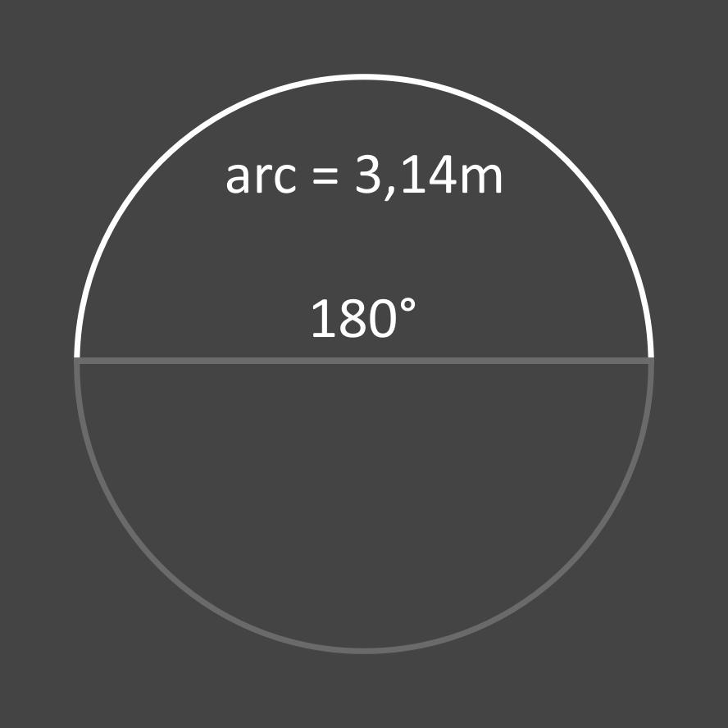
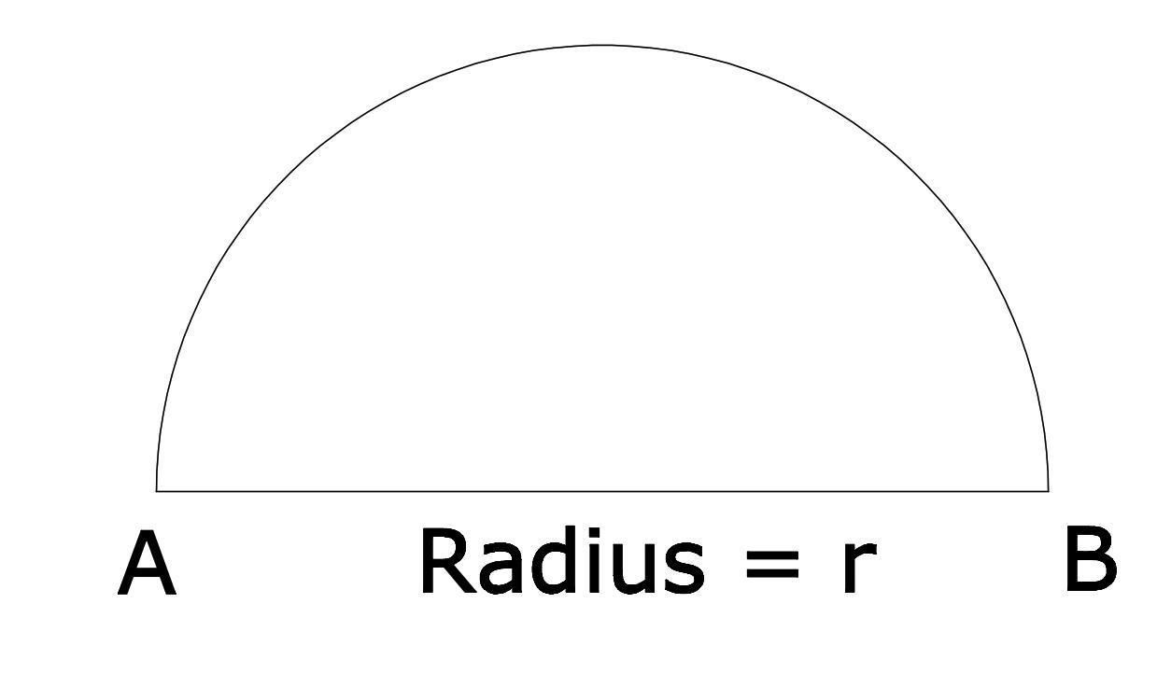
Definition
A Semicircular Path is half of a circular path.
Its central angle is:
$$\boxed{{180}^{∘}=π}$$
Arc Length
$$\boxed{s=πr}$$
Example
For:
$$r=4,$$
the semicircular path length is:
$$s=4π.$$

4. Quarter-Circular Path
# Source: AI Source: Provided by: [Data Path: Persons Table -> ID Column: 1, Name_En Column: Motasem Essam] -> From: [ChatGPT] on [7/25/2026]
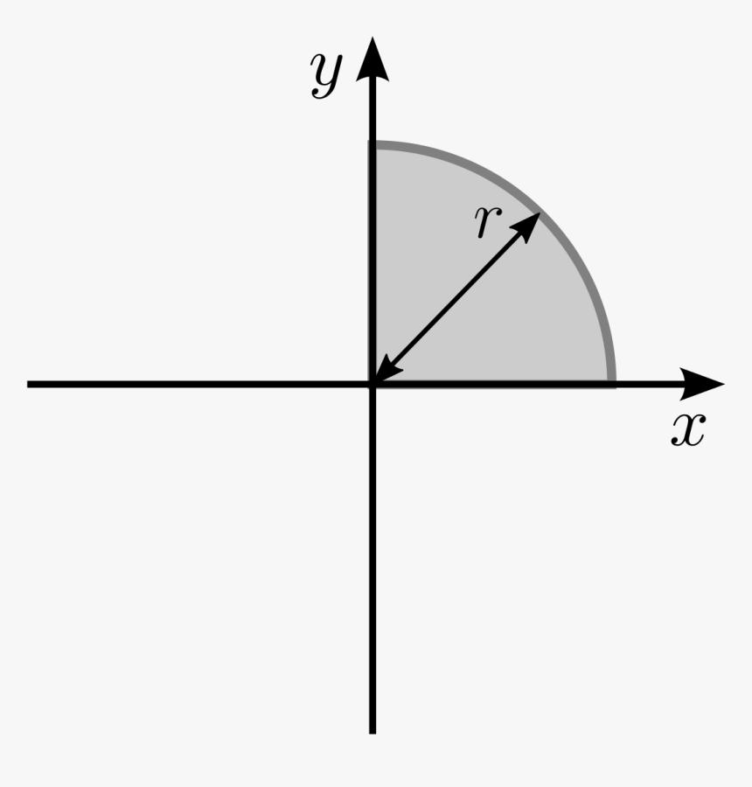
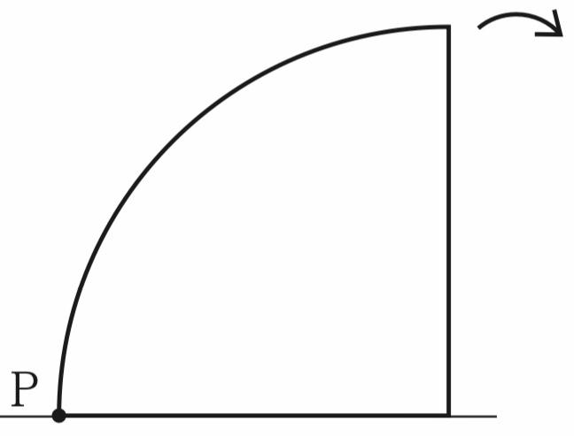
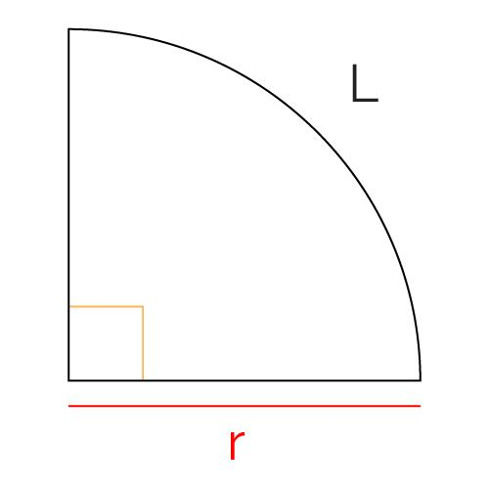
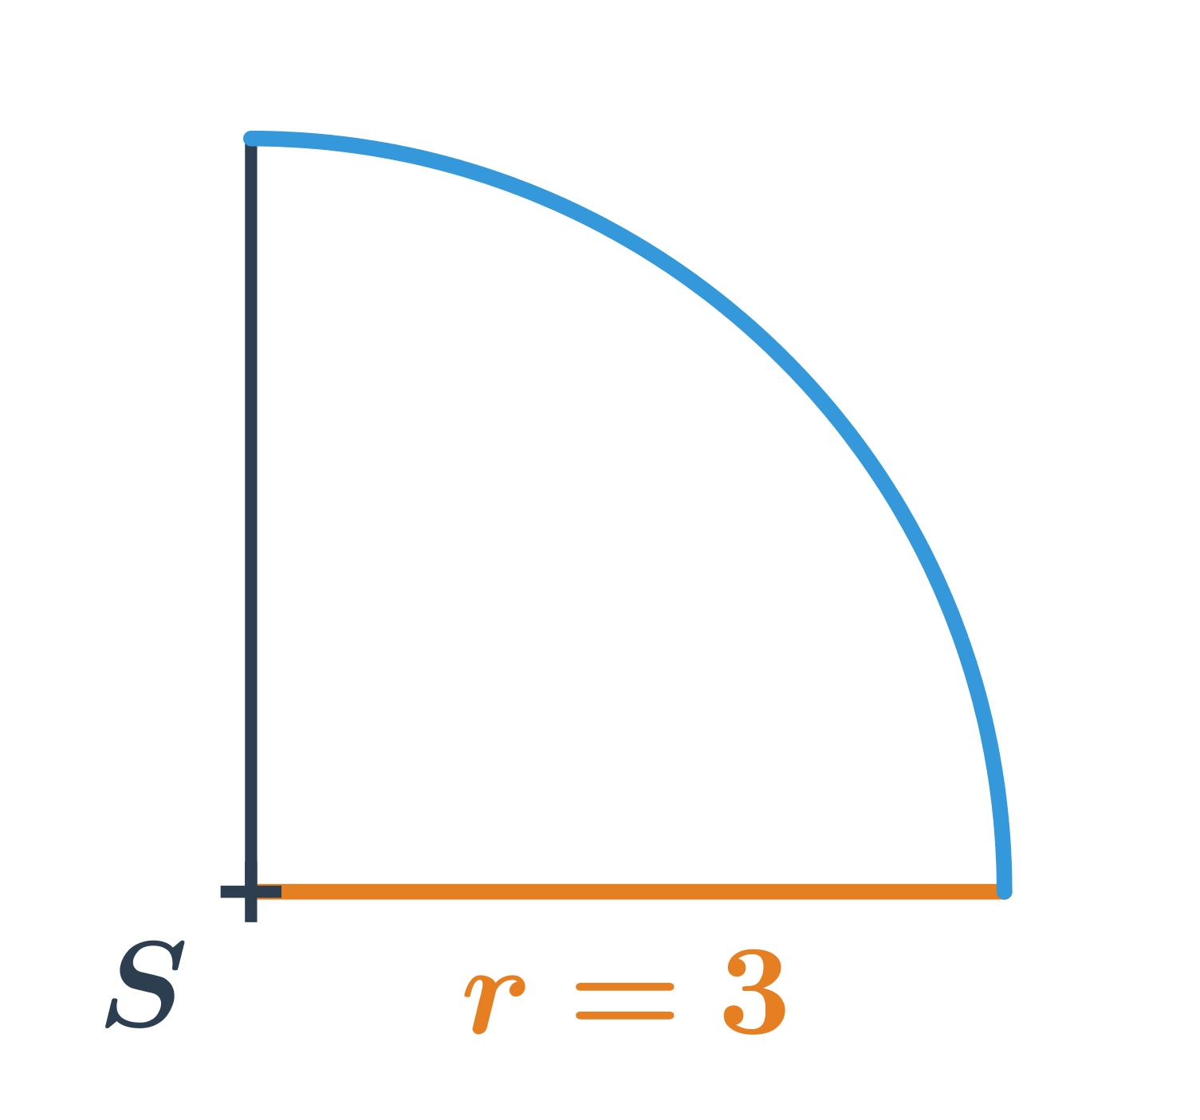
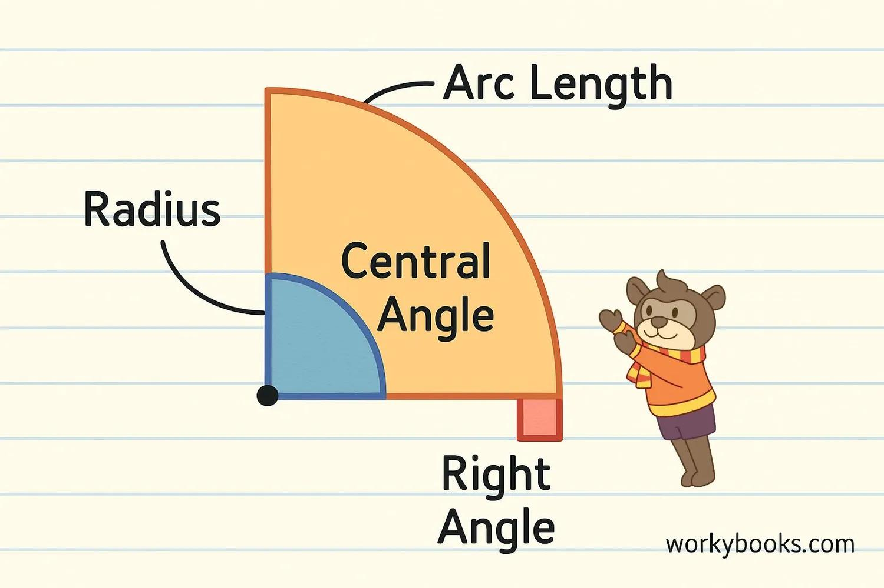
Definition
A Quarter-Circular Path is one-fourth of a full circle.
Its central angle is:
$$\boxed{{90}^{∘}=\frac{π}{2}}$$
Arc Length
$$s=\frac{πr}{2}.$$
Example
If:
$$r=8,$$
then:
$$\boxed{s=4π}.$$

5. Minor-Arc Path
# Source: AI Source: Provided by: [Data Path: Persons Table -> ID Column: 1, Name_En Column: Motasem Essam] -> From: [ChatGPT] on [7/25/2026]
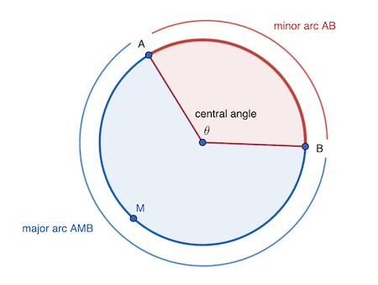
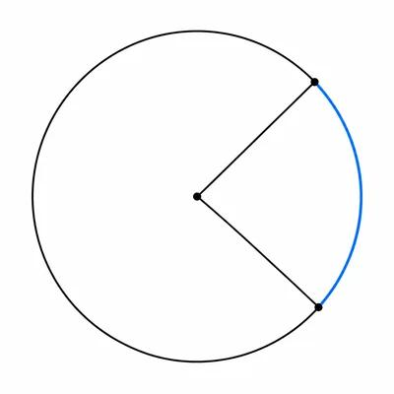
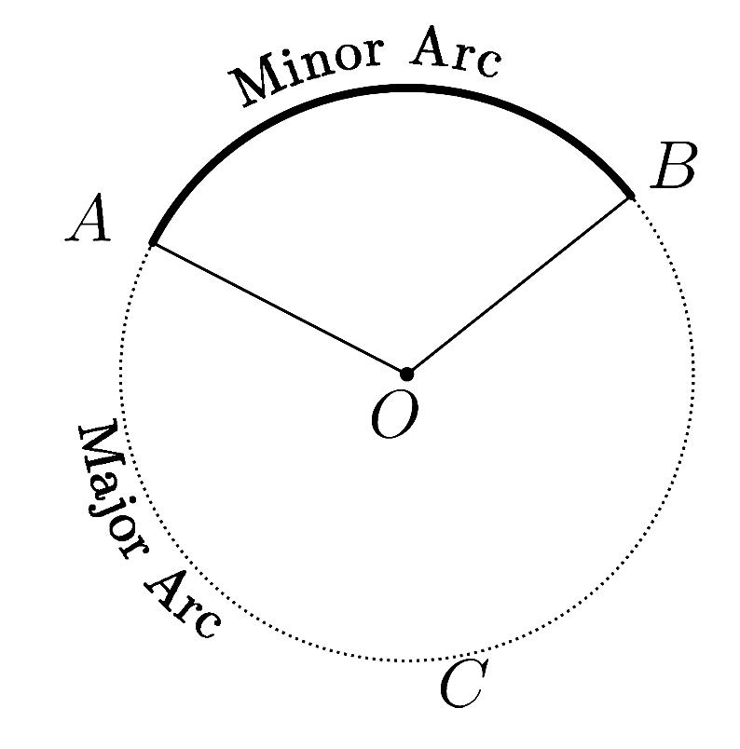
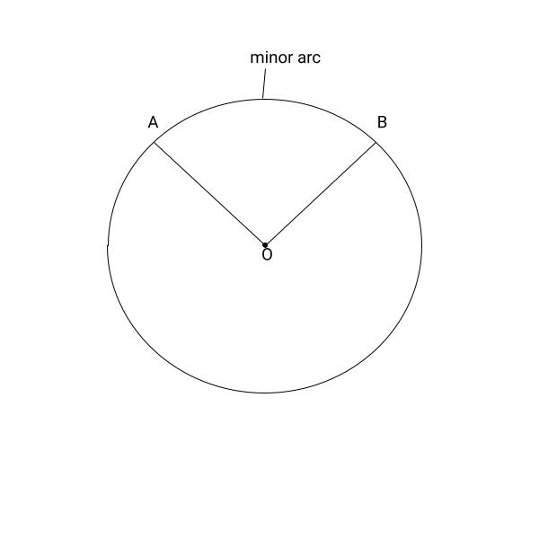
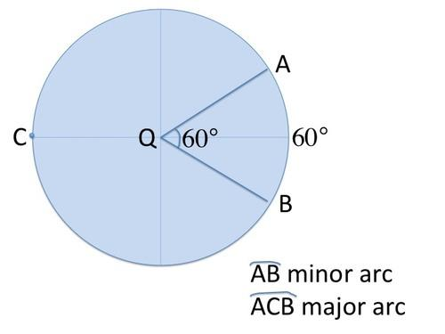
Definition
A Minor-Arc Path is the shorter arc between two points on a circle.
Its central angle satisfies:
$$\boxed{0^{∘}<θ<{180}^{∘}}$$
Example
If:
$$θ={90}^{∘},$$
the corresponding arc is a minor arc.
Its length is:
$$s=\frac{90}{360}\left(2πr\right) \\ \boxed{s=\frac{πr}{2}}.$$

6. Major-Arc Path
# Source: AI Source: Provided by: [Data Path: Persons Table -> ID Column: 1, Name_En Column: Motasem Essam] -> From: [ChatGPT] on [7/25/2026]
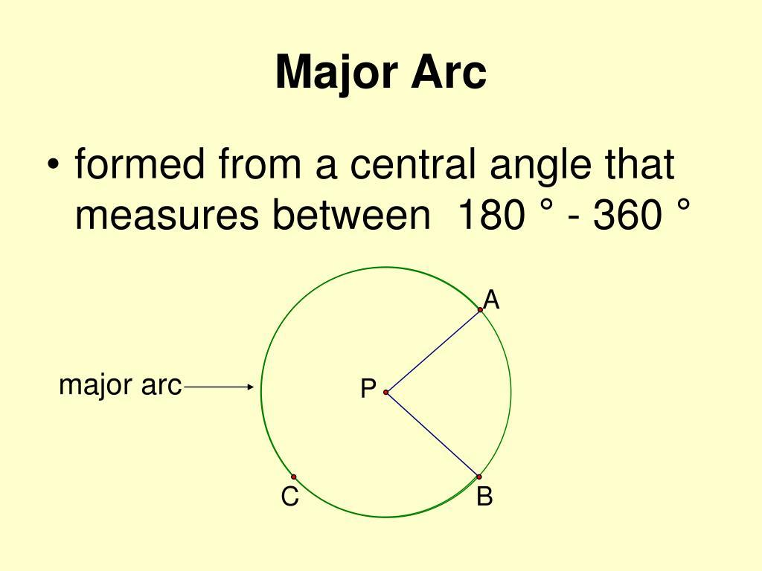
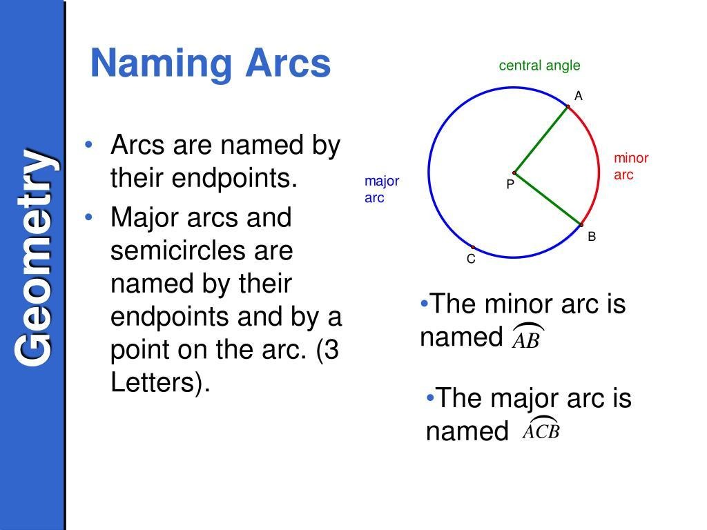
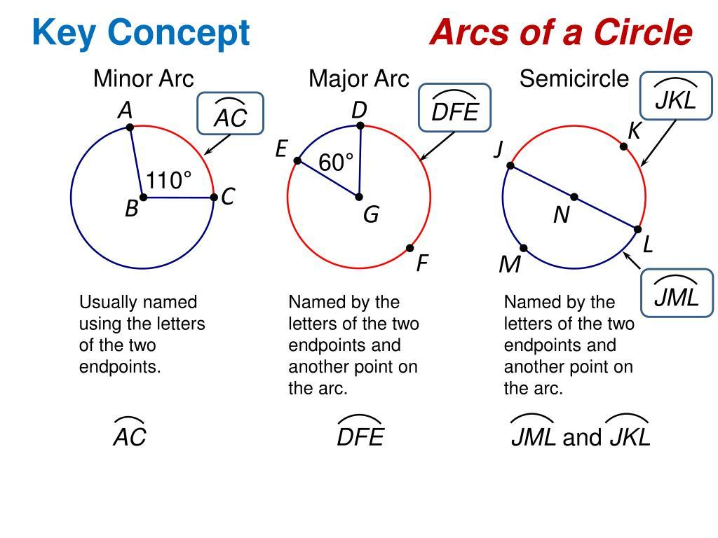
Definition
A Major-Arc Path is the longer arc between two points on a circle.
Its corresponding central angle satisfies:
$$\boxed{{180}^{∘}<θ<{360}^{∘}}.$$
Example
If the minor arc has central angle:
$${90}^{∘},$$
the major arc has:
$${360}^{∘}-{90}^{∘}={270}^{∘}.$$

7. Clockwise Circular Path
# Source: AI Source: Provided by: [Data Path: Persons Table -> ID Column: 1, Name_En Column: Motasem Essam] -> From: [ChatGPT] on [7/25/2026]
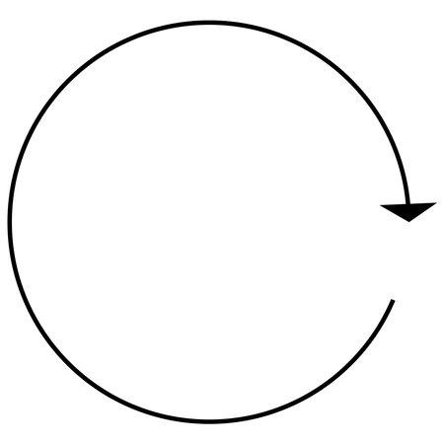
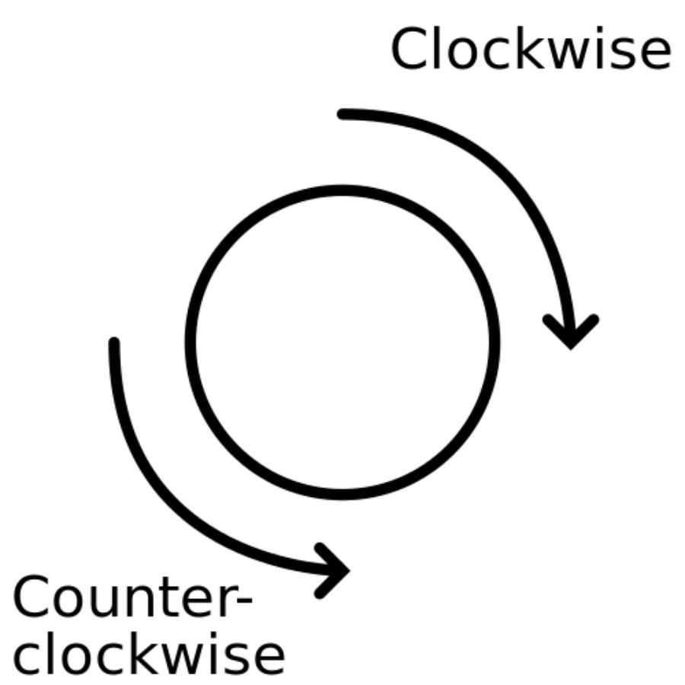
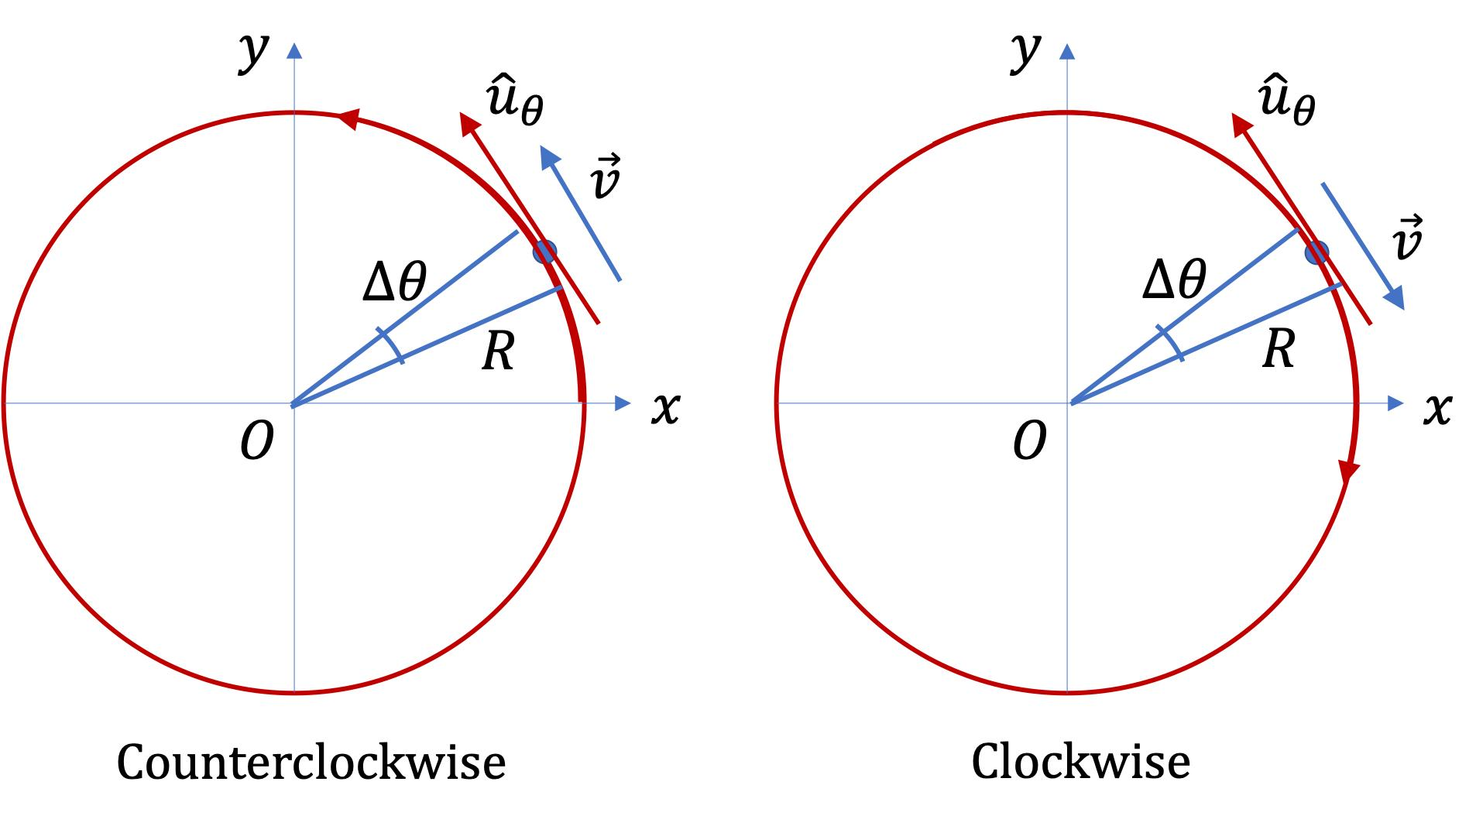
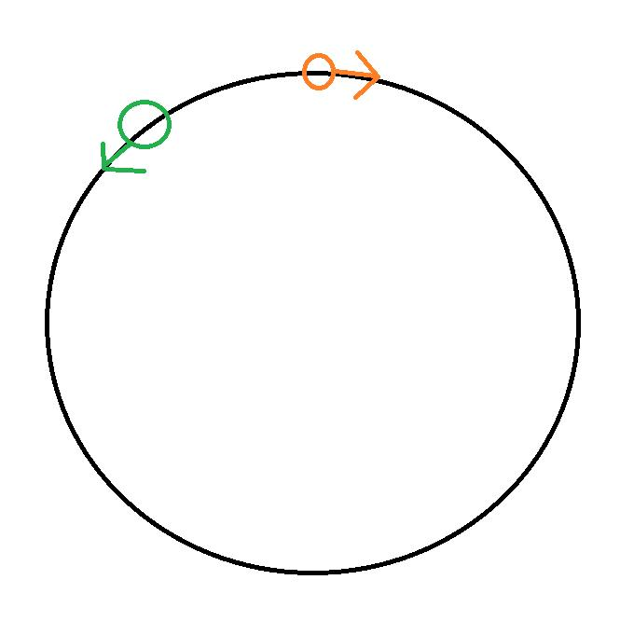
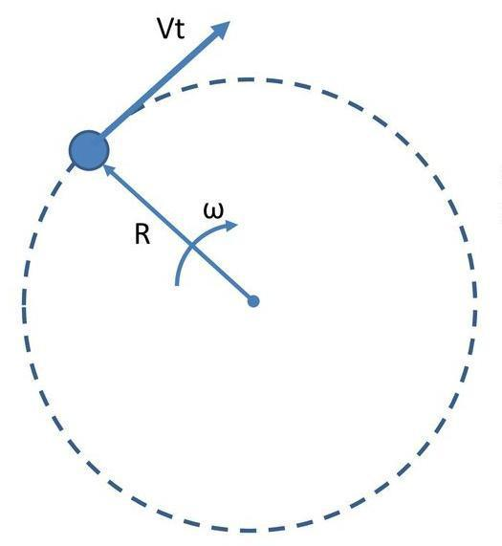
Definition
A Clockwise Circular Path is a circular path traversed in the clockwise direction.
The angular coordinate decreases with time if the usual positive direction is counterclockwise.
Example
A point moving around a clock face from 12 toward 3, 6, and 9 follows a clockwise circular path.

8. Counterclockwise Circular Path
# Source: AI Source: Provided by: [Data Path: Persons Table -> ID Column: 1, Name_En Column: Motasem Essam] -> From: [ChatGPT] on [7/25/2026]
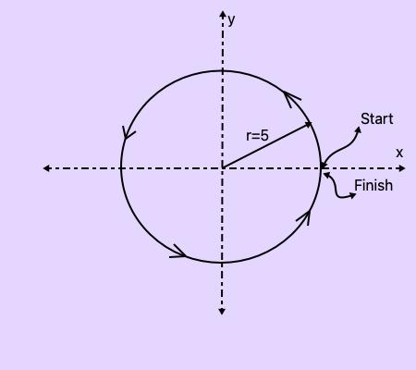
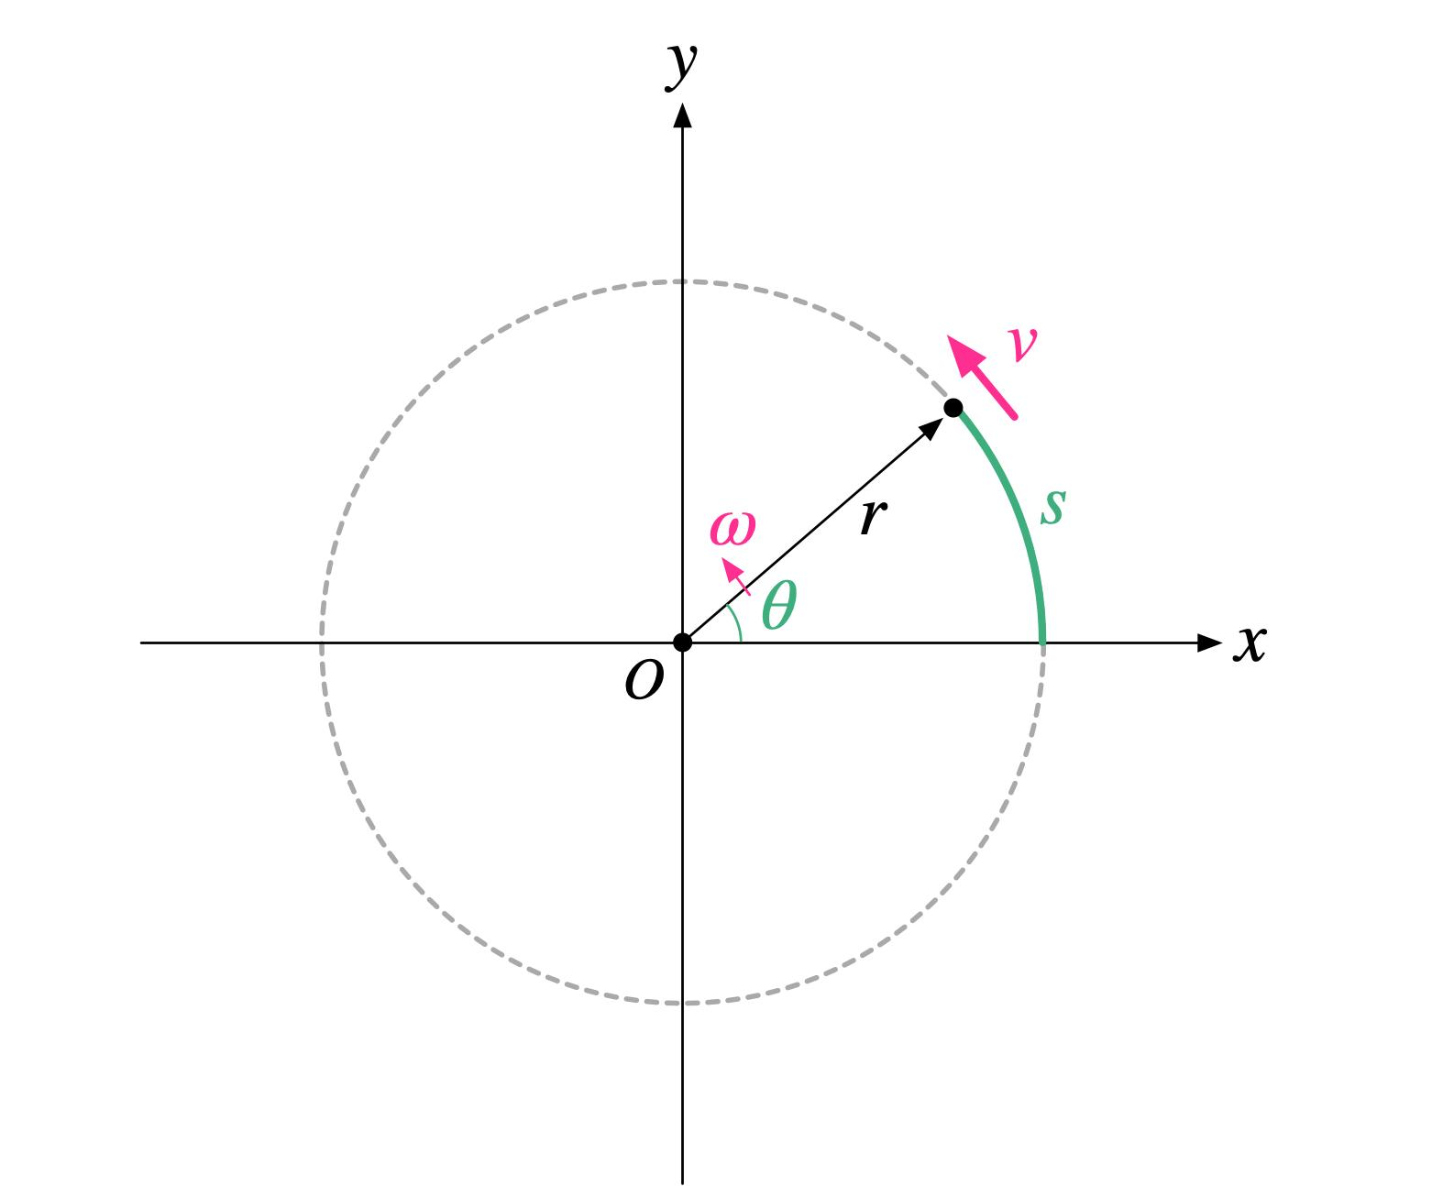
Definition
A Counterclockwise Circular Path is a circular path traversed in the counterclockwise direction.
In standard mathematics, counterclockwise angular displacement is usually positive.
Example
A point moving from 3 toward 12, 9, and 6 follows a counterclockwise path.

9. Uniform Circular Path
# Source: AI Source: Provided by: [Data Path: Persons Table -> ID Column: 1, Name_En Column: Motasem Essam] -> From: [ChatGPT] on [7/25/2026]
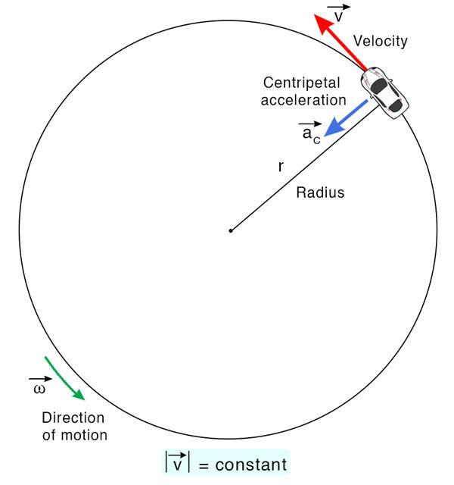
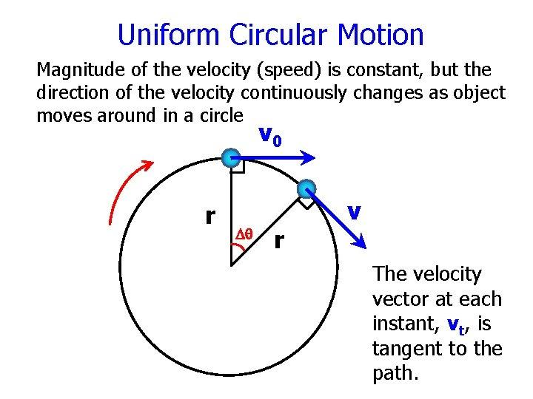
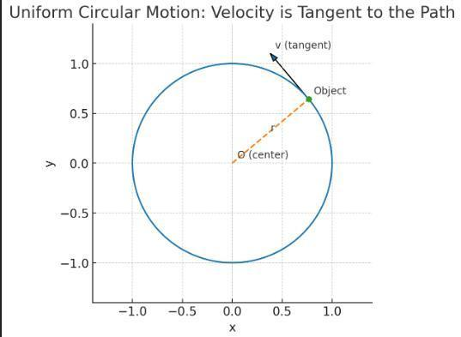
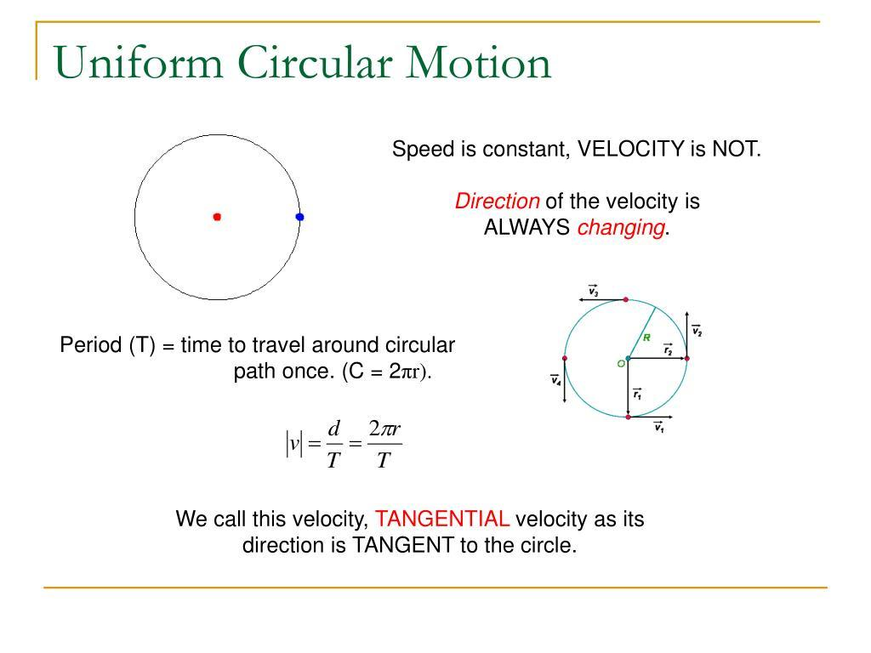
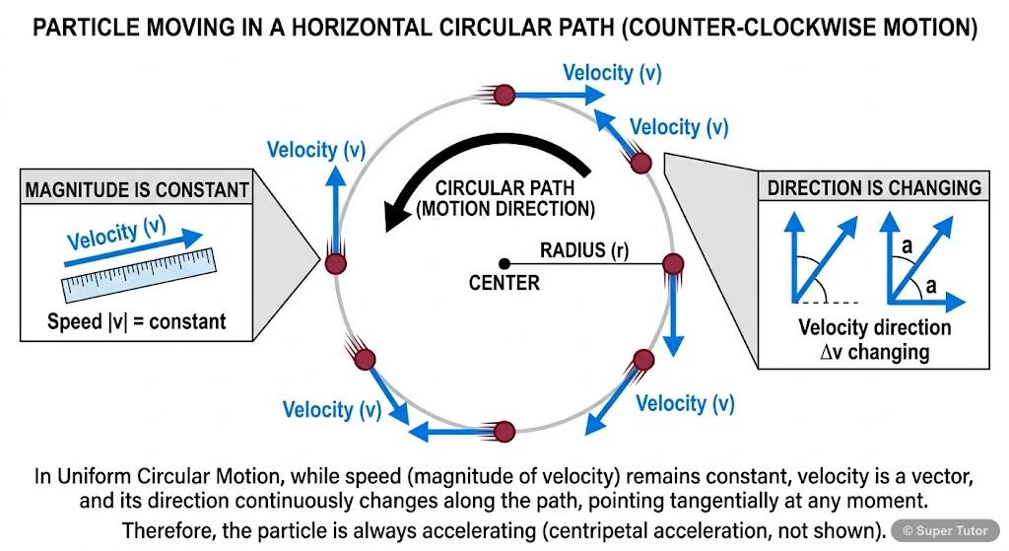
Definition
A Uniform Circular Path is a circular path traversed with constant speed.
If the angular velocity is constant:
$$\boxed{ω=\text{constant}}$$
then:
$$\boxed{θ\left(t\right)=θ_{0}+ωt}.$$
Important
Even though speed is constant, the velocity vector changes direction continuously.
The tangential speed is:
$$\boxed{v=rω}.$$
The centripetal acceleration is:
$$\boxed{a_{c}=\frac{v^{2}}{r}=rω^{2}}.$$

10. Non-Uniform Circular Path
# Source: AI Source: Provided by: [Data Path: Persons Table -> ID Column: 1, Name_En Column: Motasem Essam] -> From: [ChatGPT] on [7/25/2026]
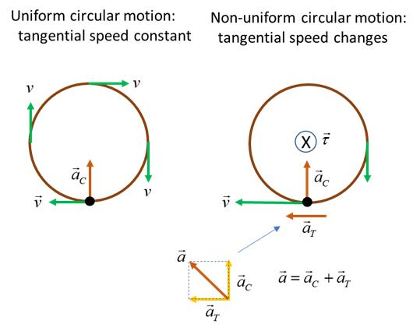
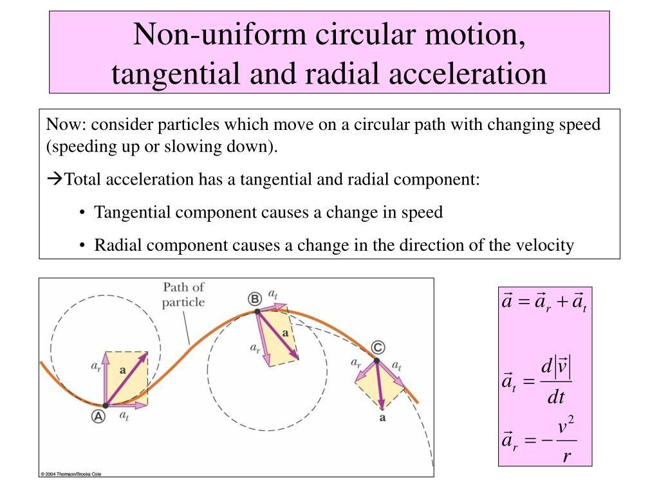
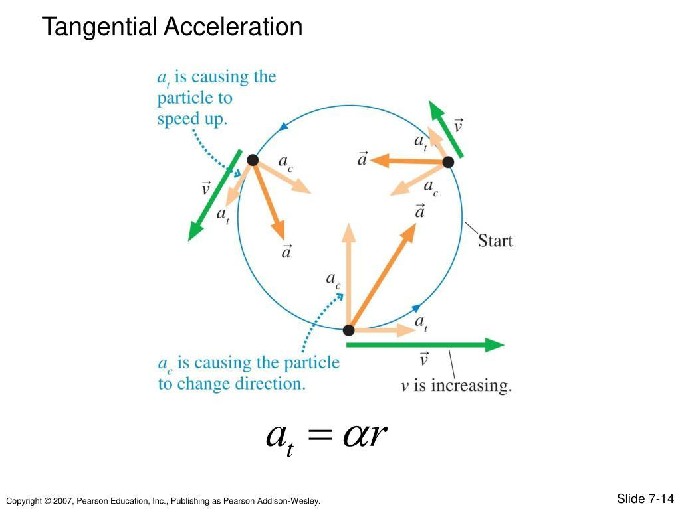
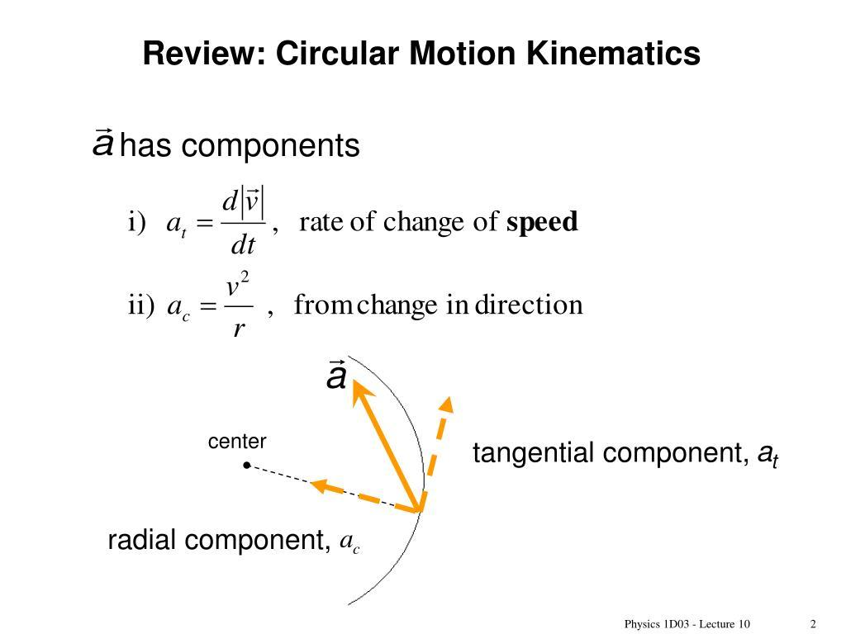
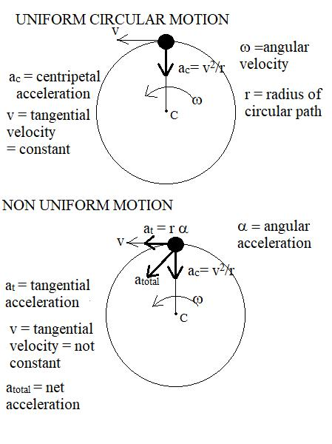
Definition
A Non-Uniform Circular Path is a circular geometric path traversed with changing speed.
The radius remains constant:
$$\boxed{r=\text{constant}}$$
but angular velocity may change:
$$\boxed{ω=ω\left(t\right)}.$$
Example
A wheel can rotate around its center while gradually speeding up. Its geometric path remains circular even though its speed changes.

11. Horizontal Circular Path
# Source: AI Source: Provided by: [Data Path: Persons Table -> ID Column: 1, Name_En Column: Motasem Essam] -> From: [ChatGPT] on [7/25/2026]
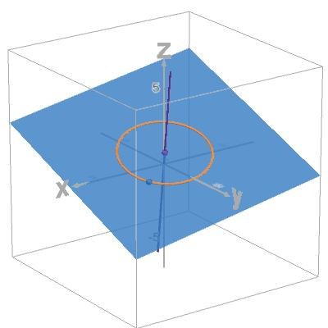
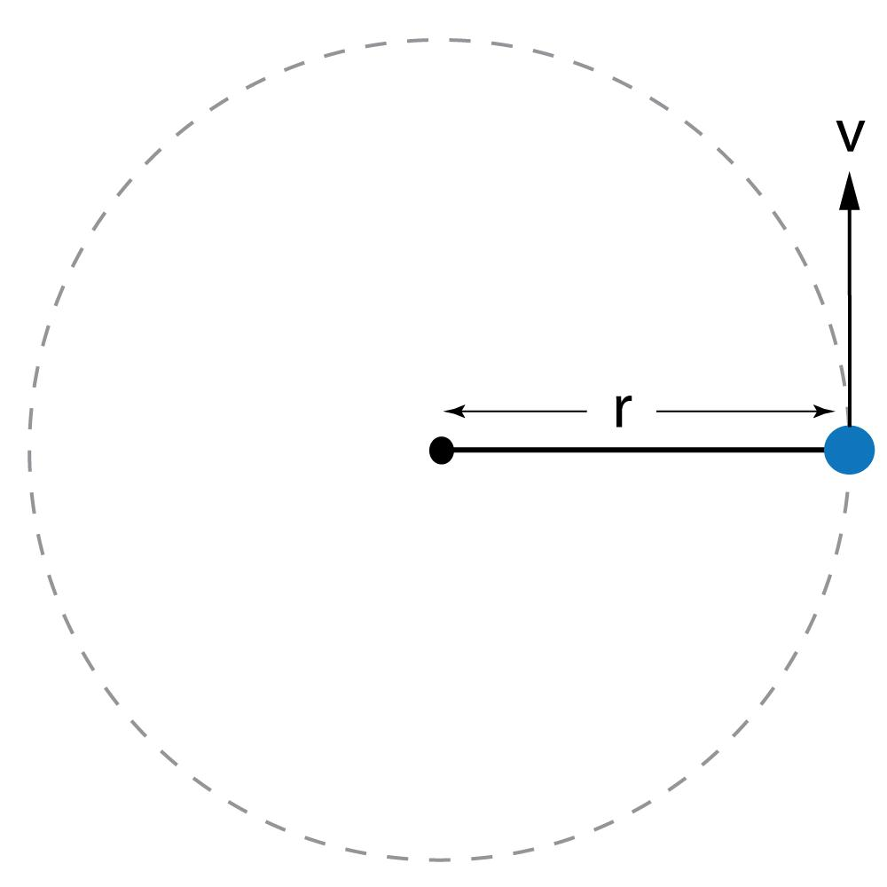
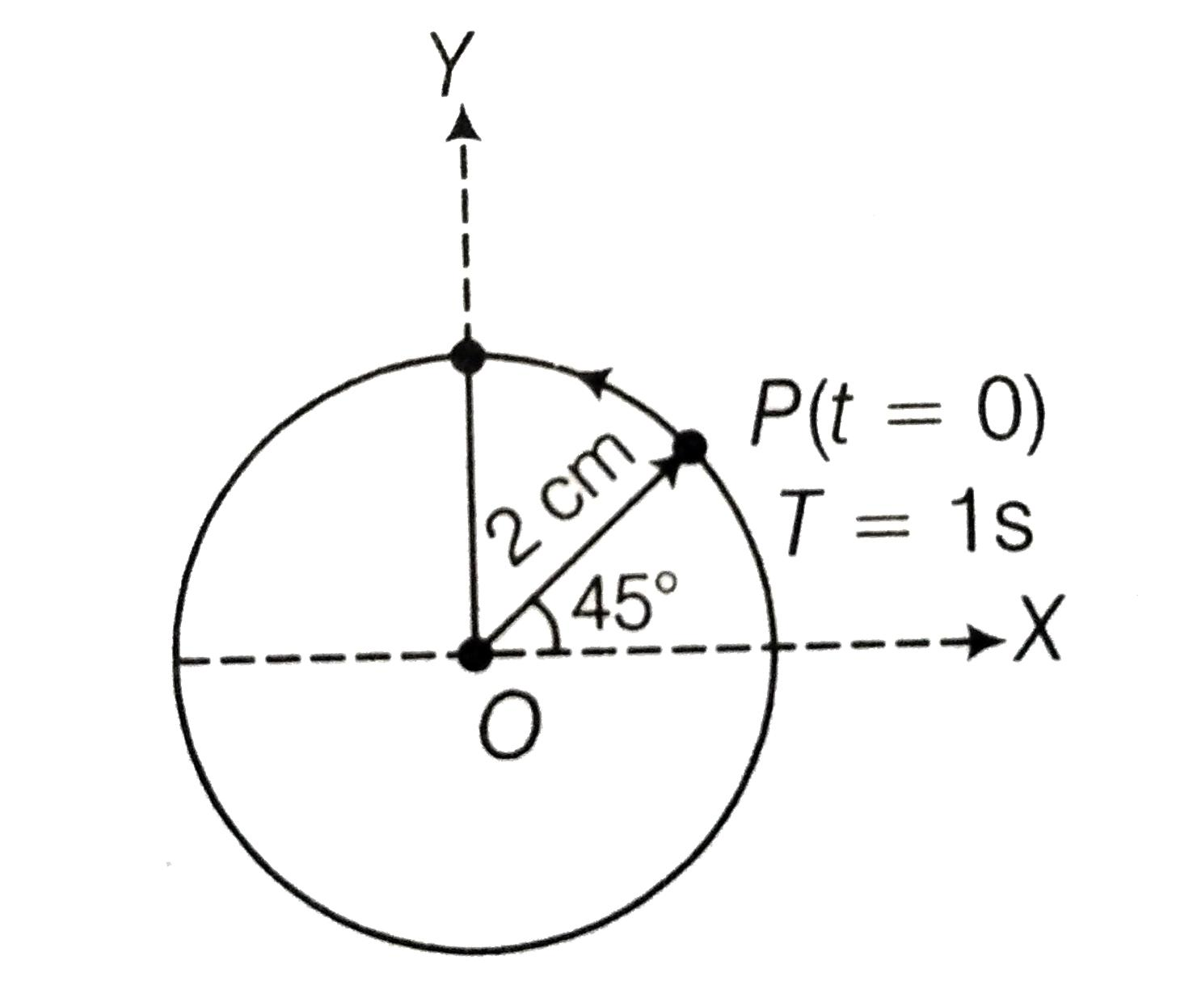
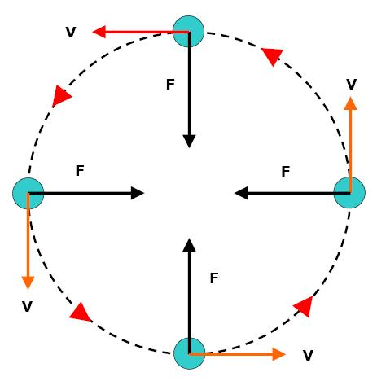
Definition
A Horizontal Circular Path lies in a horizontal plane.
For example, a point attached to a rotating object can move in a horizontal circle.
Example
A point on the edge of a rotating horizontal disk follows a horizontal circular path.

12. Vertical Circular Path
# Source: AI Source: Provided by: [Data Path: Persons Table -> ID Column: 1, Name_En Column: Motasem Essam] -> From: [ChatGPT] on [7/25/2026]
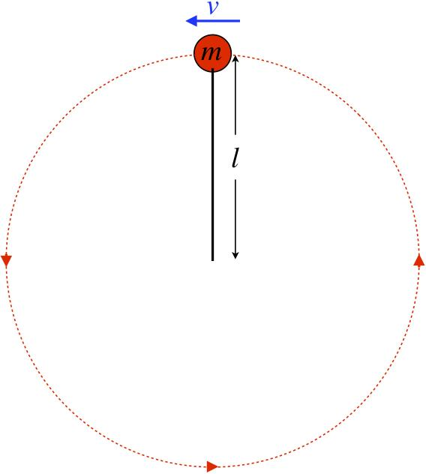
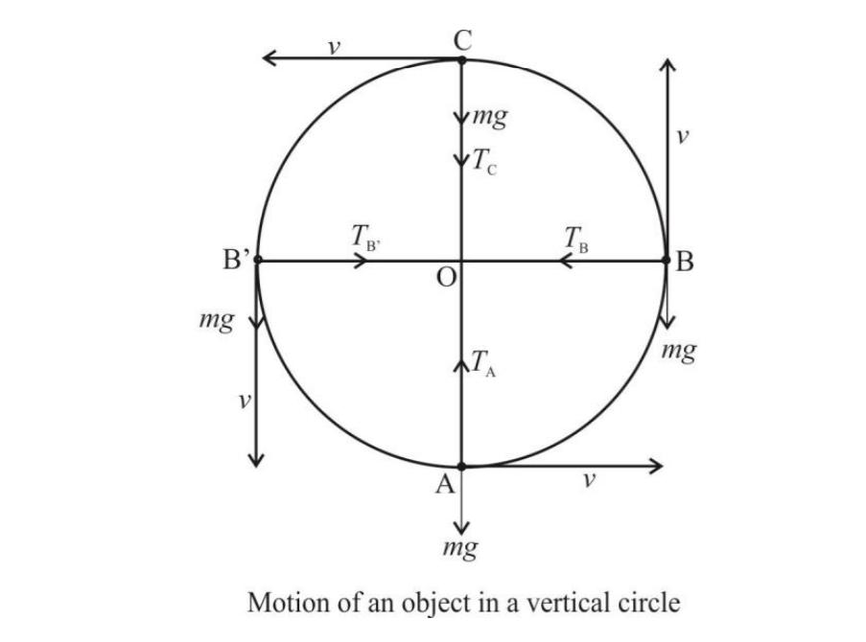
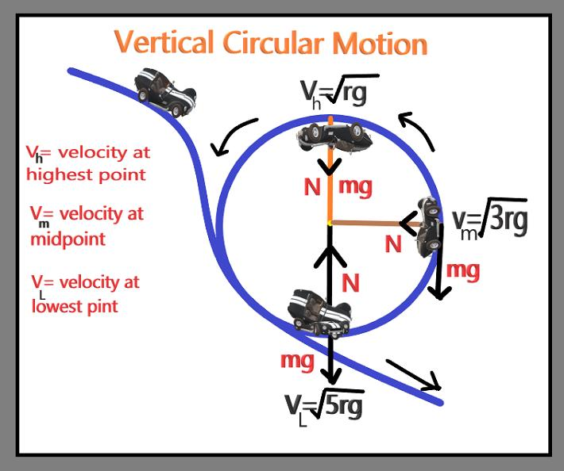
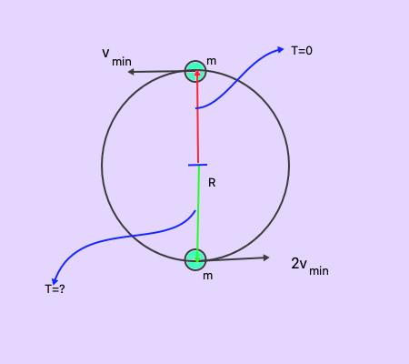
Definition
A Vertical Circular Path lies in a vertical plane.
Example
A point on a Ferris wheel follows a vertical circular path.
The point remains at constant distance from the wheel's center:
$$\boxed{OP=r}.$$

13. Inclined Circular Path
# Source: AI Source: Provided by: [Data Path: Persons Table -> ID Column: 1, Name_En Column: Motasem Essam] -> From: [ChatGPT] on [7/25/2026]
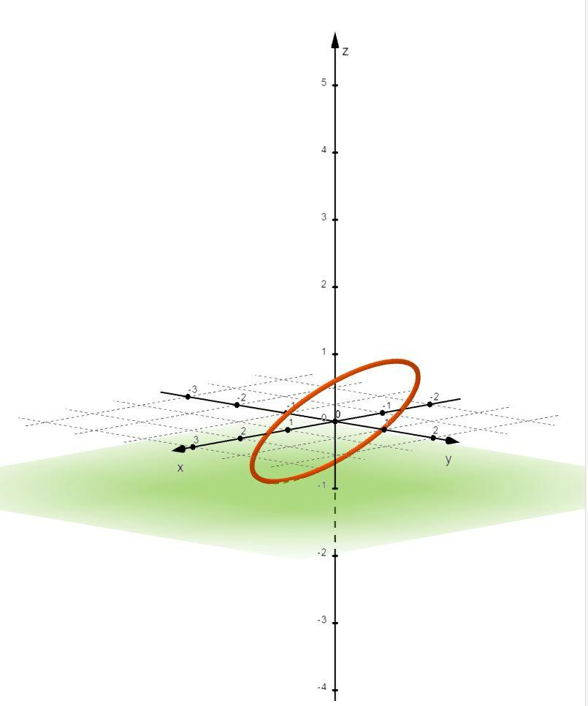
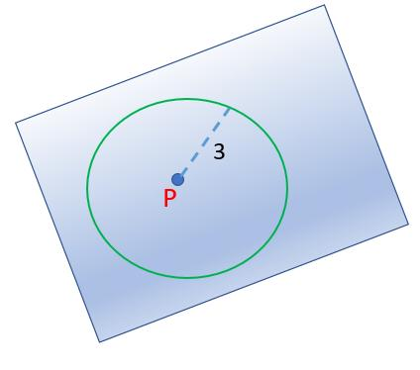
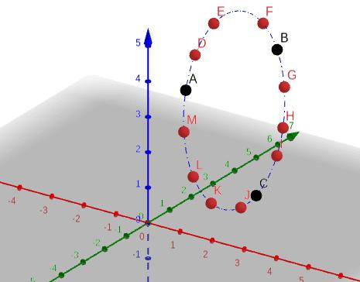
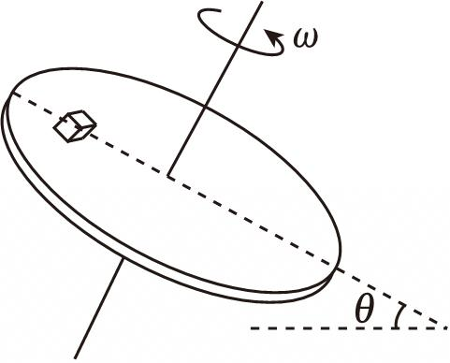
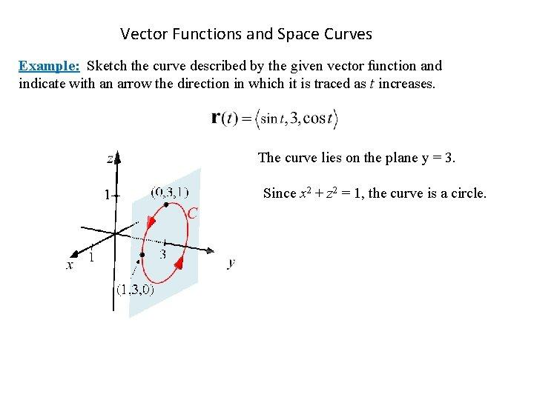
Definition
An Inclined Circular Path lies in a plane that is tilted relative to a reference plane.
Example
A point moving around the rim of a tilted circular disk follows an inclined circular path.
The path is still circular because every point remains at a constant distance from the center.

14. Coordinate Circular Path
# Source: AI Source: Provided by: [Data Path: Persons Table -> ID Column: 1, Name_En Column: Motasem Essam] -> From: [ChatGPT] on [7/25/2026]
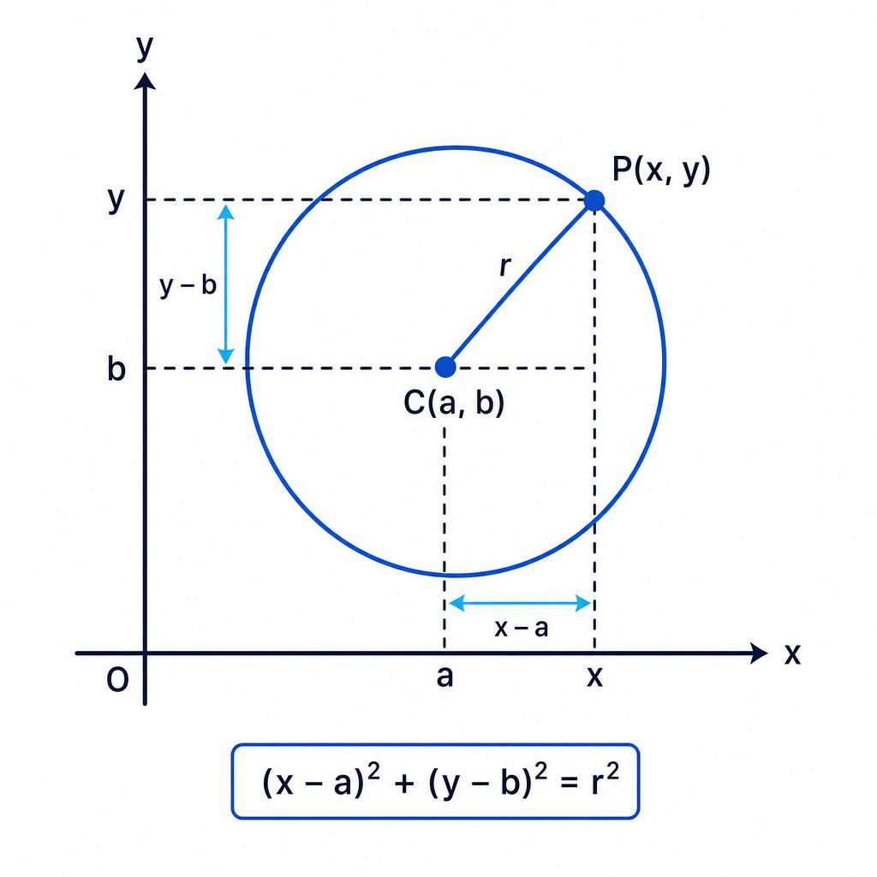
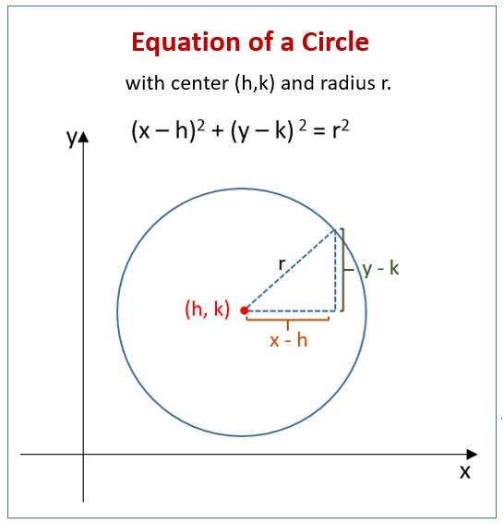
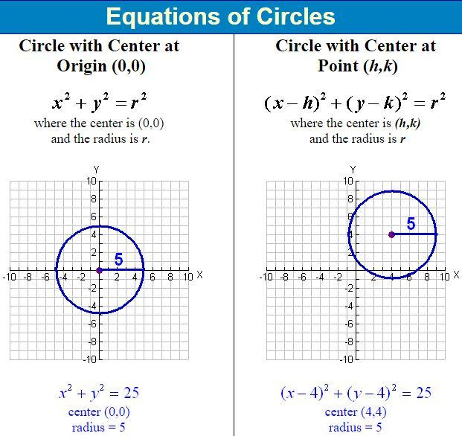
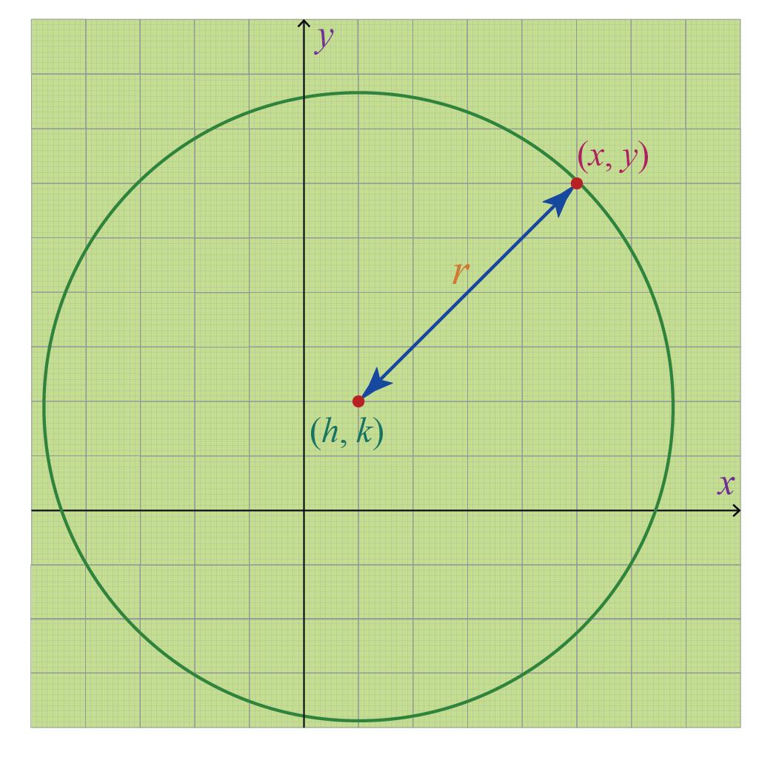
Definition
A Coordinate Circular Path is represented by an equation in a coordinate system.
For center:
$$\left(h , k\right)$$
and radius $r$:
$$\boxed{{\left(x-h\right)}^{2}+{\left(y-k\right)}^{2}=r^{2}}$$
Example
For center:
$$\left(2 , 3\right)$$
and radius:
$$5,$$
the path is:
$$\boxed{{\left(x-2\right)}^{2}+{\left(y-3\right)}^{2}=25}.$$

15. Parametric Circular Path
# Source: AI Source: Provided by: [Data Path: Persons Table -> ID Column: 1, Name_En Column: Motasem Essam] -> From: [ChatGPT] on [7/25/2026]
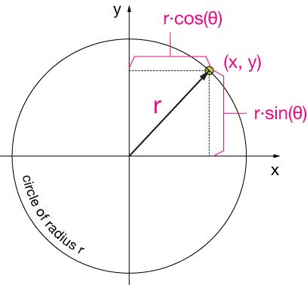
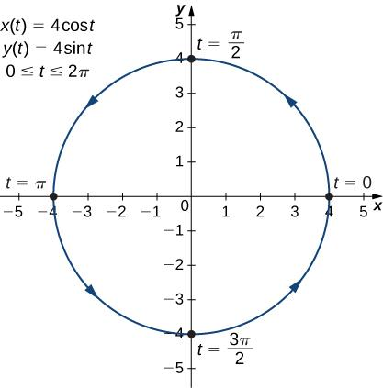
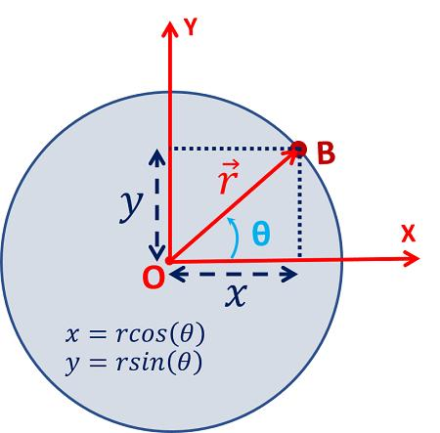
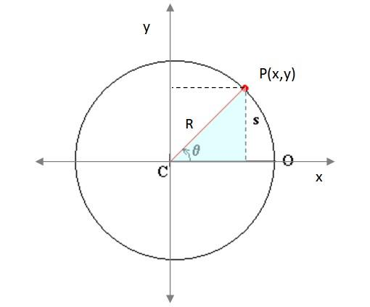
Definition
A Parametric Circular Path represents the position of a moving point using an angle parameter.
For a circle centered at the origin:
$$\boxed{x=r\cos{t}} \\ \boxed{y=r\sin{t}}$$
where:
$$0≤t<2π$$
for one complete revolution.
Example
For:
$$r=5,$$
the path is:
$$\boxed{x=5\cos{t}, y=5\sin{t}}.$$

16. Vector-Defined Circular Path
# Source: AI Source: Provided by: [Data Path: Persons Table -> ID Column: 1, Name_En Column: Motasem Essam] -> From: [ChatGPT] on [7/25/2026]
Definition
A circular path can also be described using vectors.
For a circle centered at $O$:
$$\boxed{\vec{r}\left(t\right)={\vec{r}}_{O}+r\left(\begin{matrix}\cos{t} \\ \sin{t}\end{matrix}\right)}$$
Example
For:
$$O=\left(2 , 1\right)$$
and:
$$r=3,$$
we have:
$$\boxed{\vec{r}\left(t\right)=\left(\begin{matrix}2 \\ 1\end{matrix}\right)+3\left(\begin{matrix}\cos{t} \\ \sin{t}\end{matrix}\right)}.$$

17. Restricted Circular Path
# Source: AI Source: Provided by: [Data Path: Persons Table -> ID Column: 1, Name_En Column: Motasem Essam] -> From: [ChatGPT] on [7/25/2026]
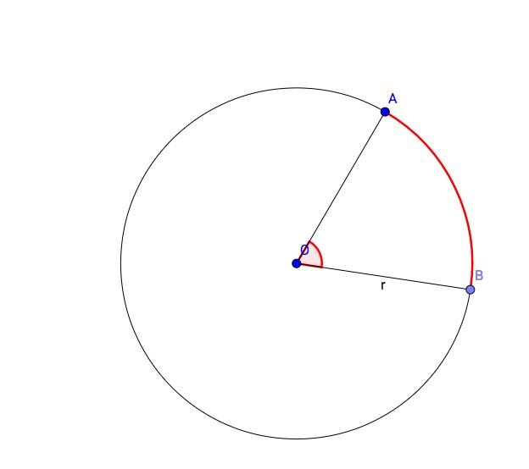
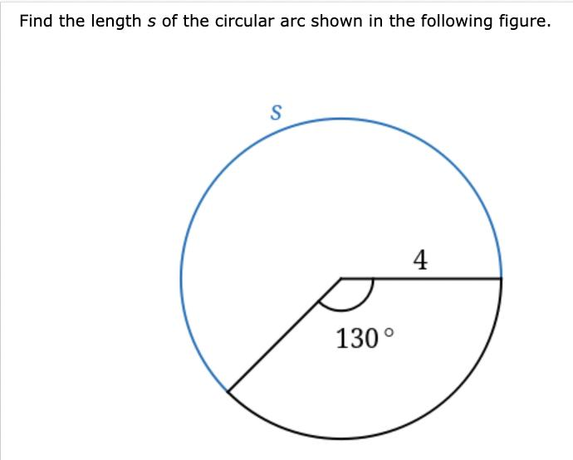
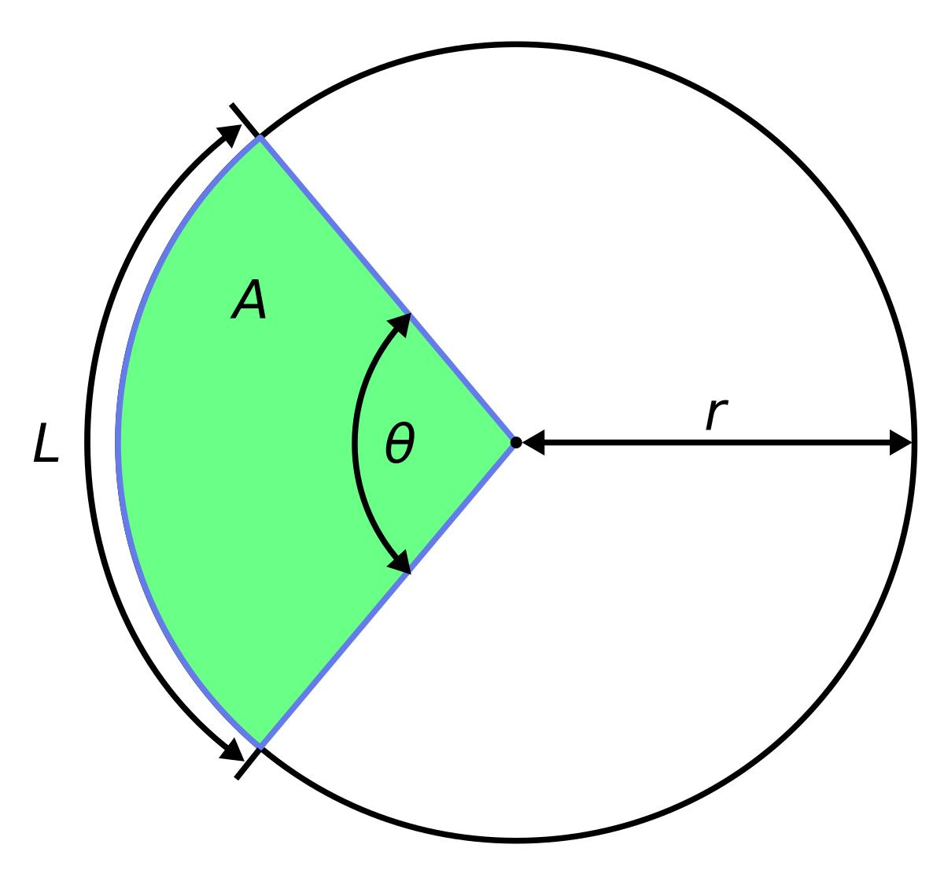
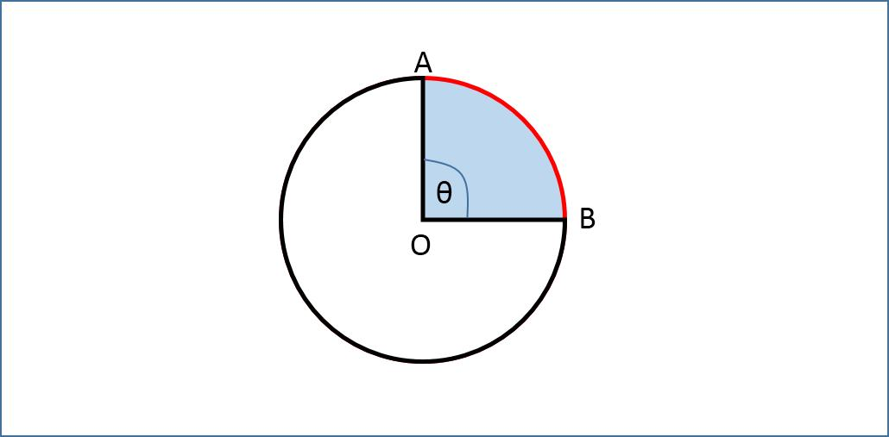
Definition
A Restricted Circular Path is only a specified portion of a circle.
Example
A circle is given by:
$$x^{2}+y^{2}=25$$
but the point is restricted to:
$$0≤θ≤{90}^{∘}.$$
The path is only the first-quadrant quarter-circle.

18. Concentric Circular Paths
# Source: AI Source: Provided by: [Data Path: Persons Table -> ID Column: 1, Name_En Column: Motasem Essam] -> From: [ChatGPT] on [7/25/2026]
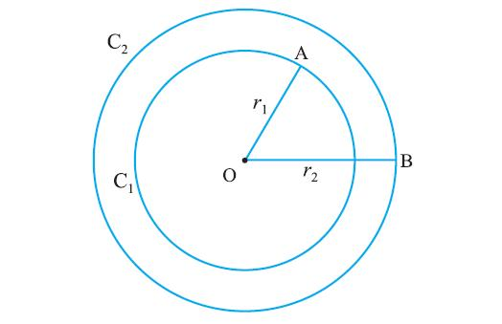
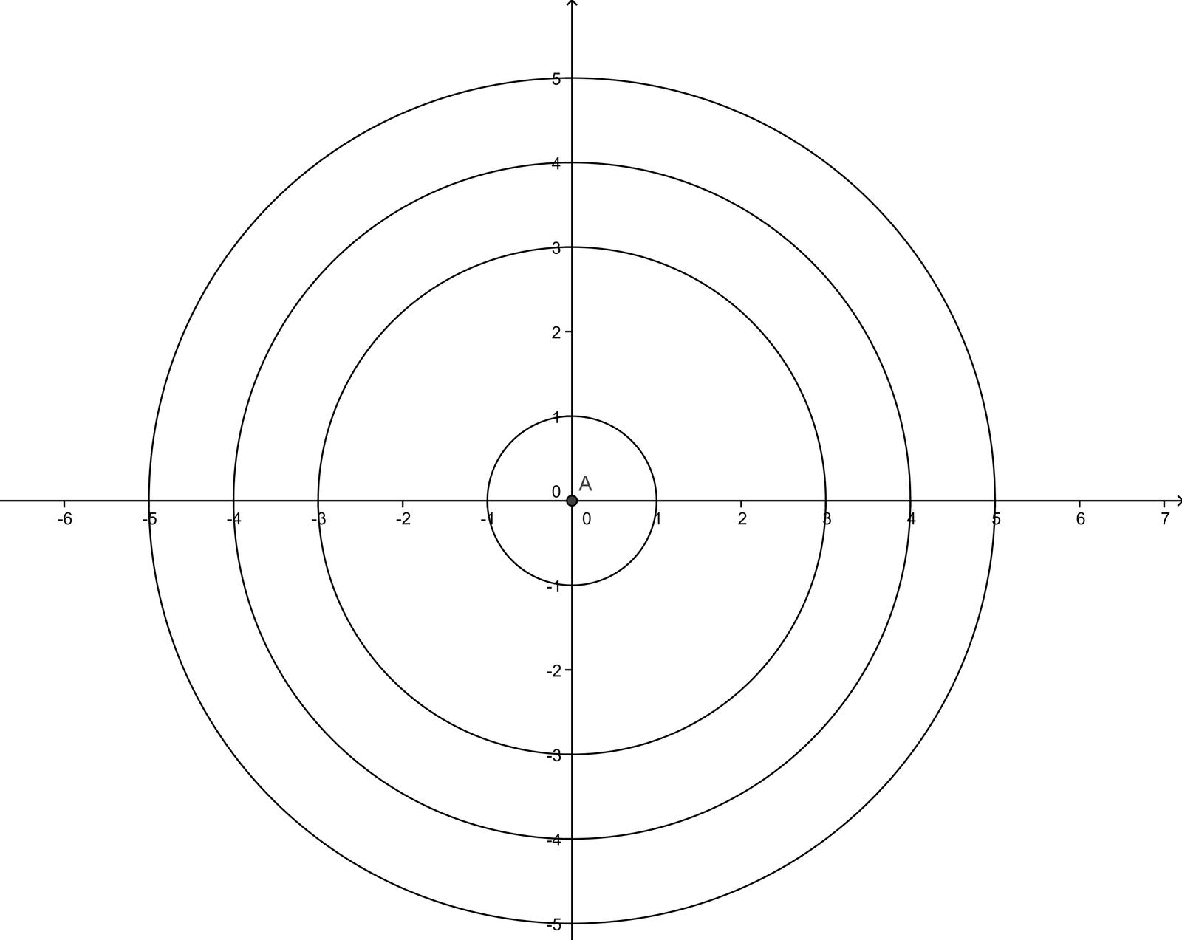
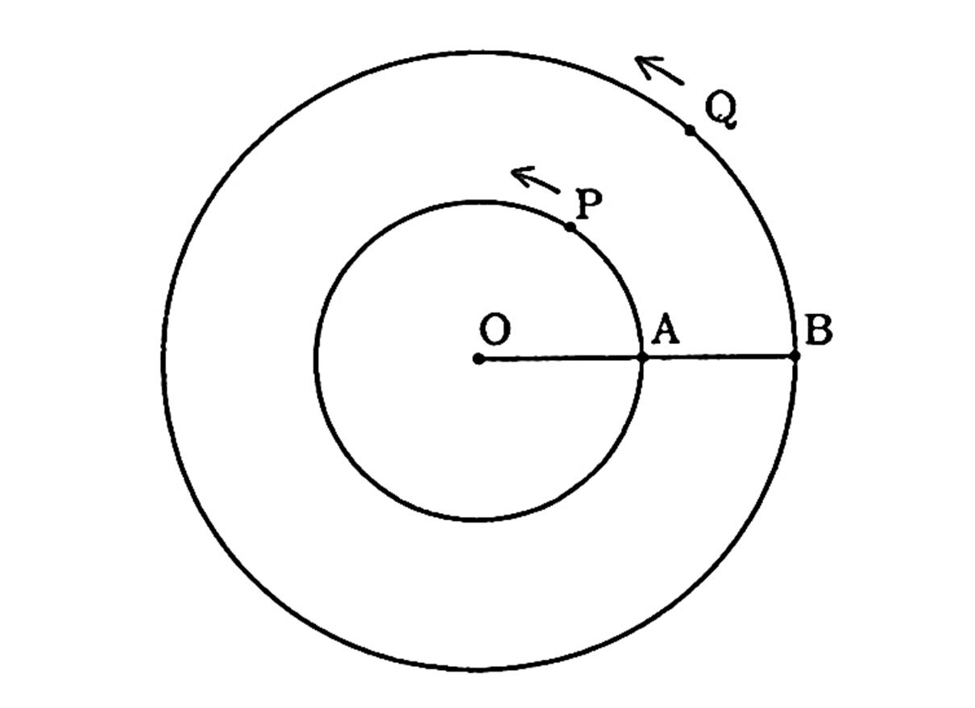
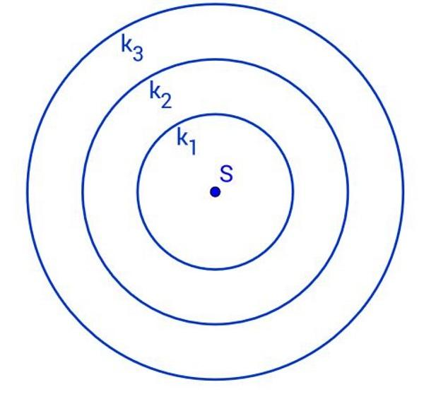
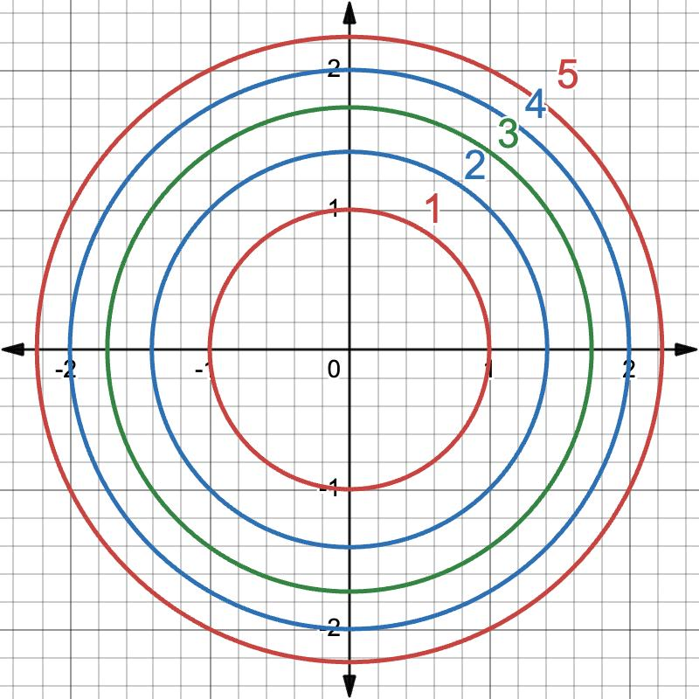
Definition
Concentric Circular Paths are circular paths sharing the same center but having different radii.
If:
$$O$$
is common to two paths:
$$OP_{1}=r_{1}$$
and:
$$OP_{2}=r_{2},$$
then:
$$\boxed{r_{1}≠r_{2}}$$
for distinct paths.
Example
Two circular paths with radii:
$$5$$
and:
$$10$$
have the same center but different circumferences.

19. Offset Circular Path
# Source: AI Source: Provided by: [Data Path: Persons Table -> ID Column: 1, Name_En Column: Motasem Essam] -> From: [ChatGPT] on [7/25/2026]
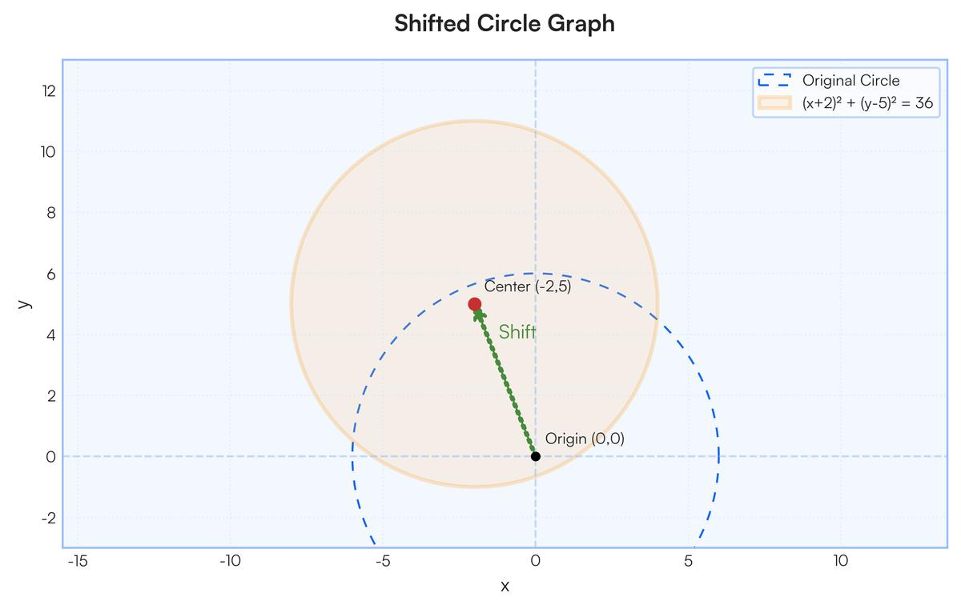
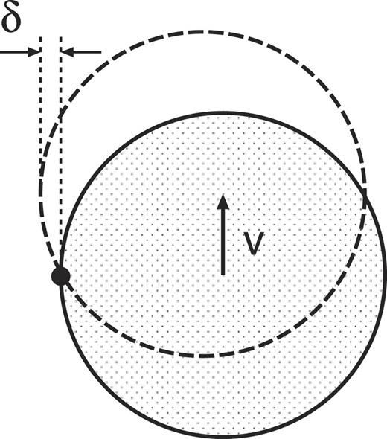
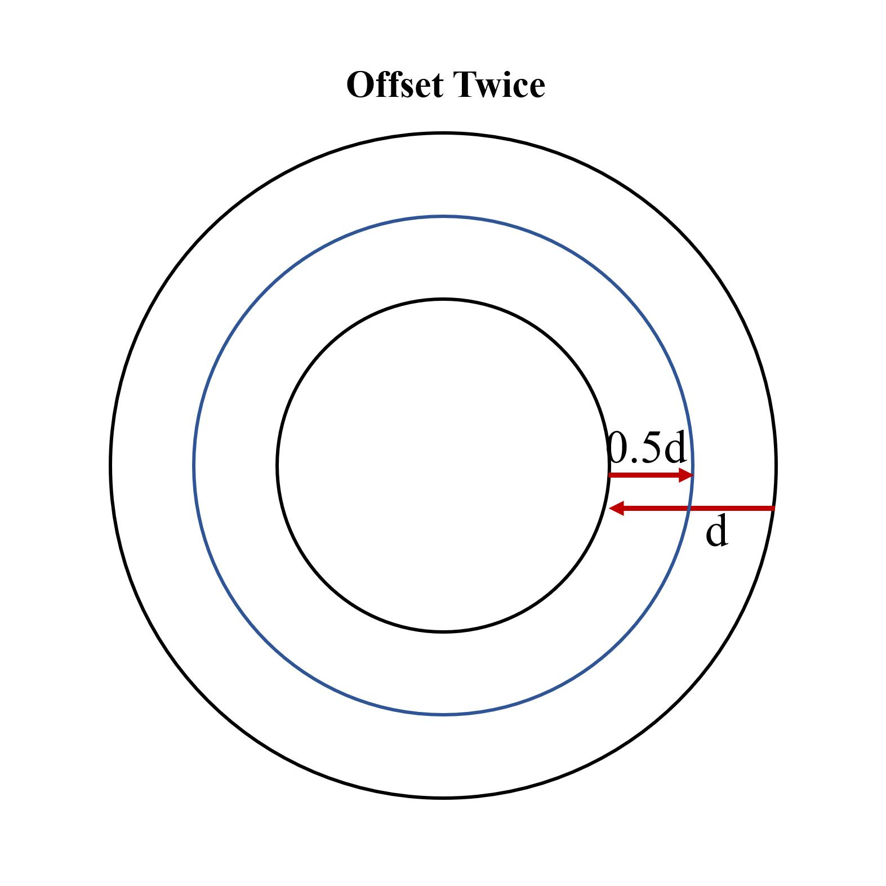
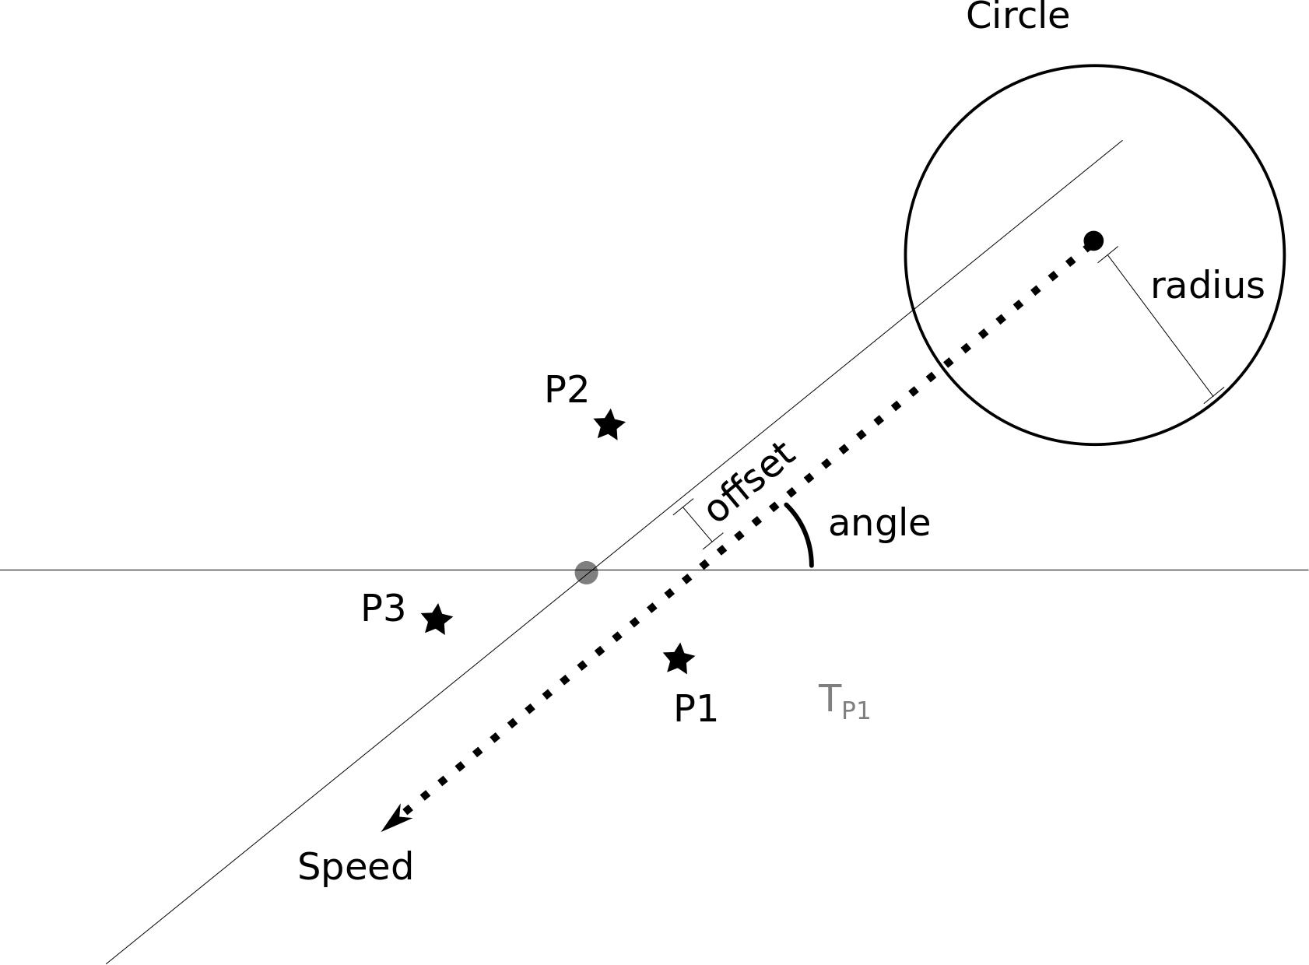
Definition
An Offset Circular Path is a circular path whose center is displaced from a reference point, axis, or coordinate origin.
Example
A circle centered at:
$$\left(4 , 3\right)$$
instead of the origin has:
$$\boxed{{\left(x-4\right)}^{2}+{\left(y-3\right)}^{2}=r^{2}}.$$
The circle remains circular; only its position changes.

20. Combined Circular Path
# Source: AI Source: Provided by: [Data Path: Persons Table -> ID Column: 1, Name_En Column: Motasem Essam] -> From: [ChatGPT] on [7/25/2026]
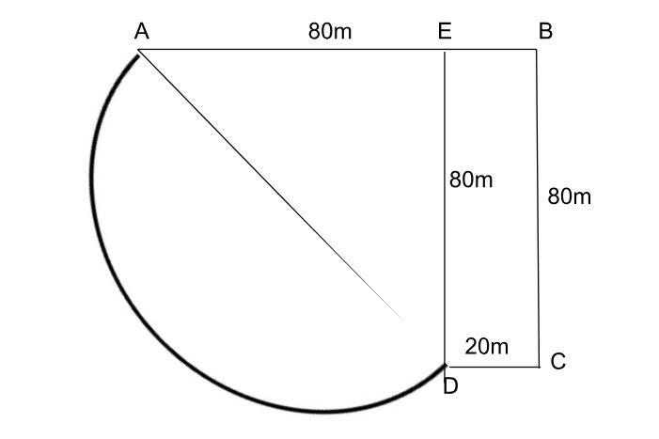
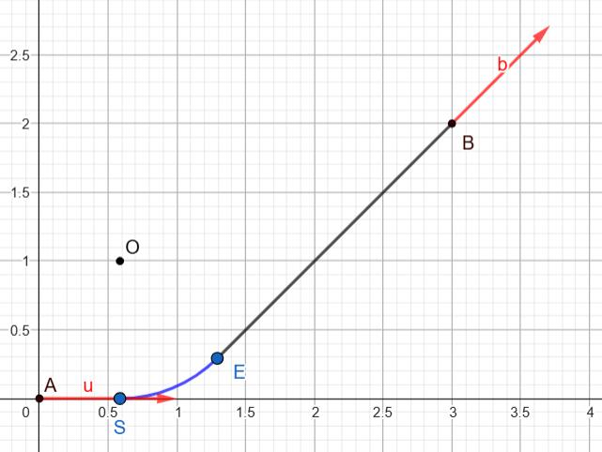
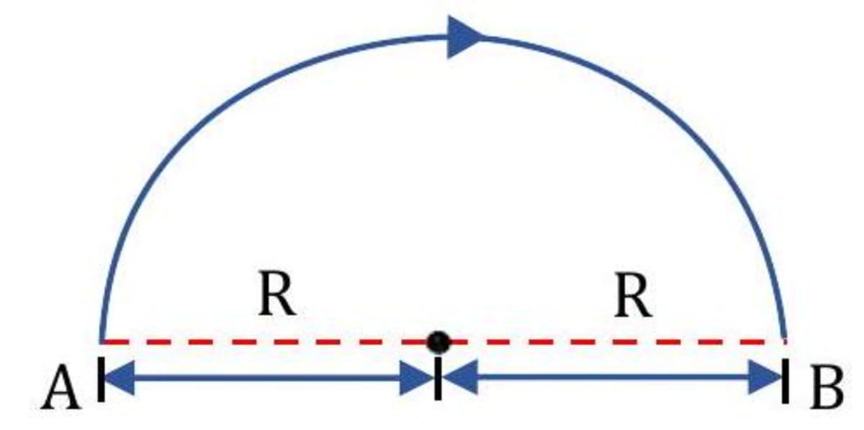
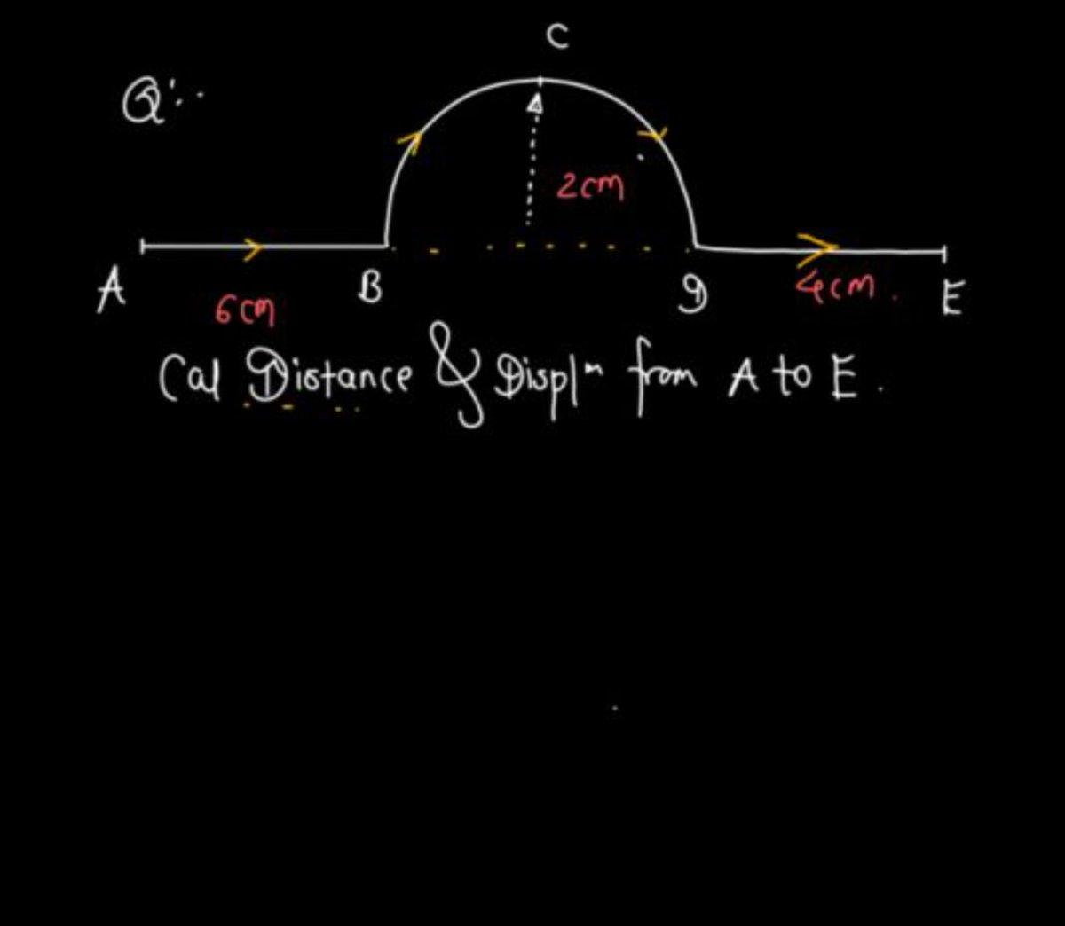
Definition
A Combined Circular Path contains one or more circular portions together with other types of paths.
Example
A path could be:
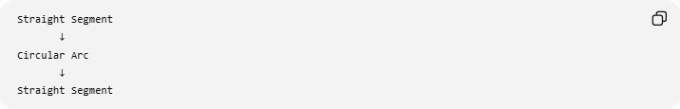
Straight Segment
↓
Circular Arc
↓
Straight Segment
For example:
$$A→B$$
along a straight segment,
then:
$$B→C$$
along a circular arc,
then:
$$C→D$$
along another straight segment.
The complete path is therefore not purely circular.

Fundamental Property of a Circular Path
# Source: AI Source: Provided by: [Data Path: Persons Table -> ID Column: 1, Name_En Column: Motasem Essam] -> From: [ChatGPT] on [7/25/2026]
The defining condition is:
$$\boxed{OP=r}$$
where:
- $O$= fixed center,
- $P$= moving point,
- $r$= constant radius.
This means:
$$OP_{1}=OP_{2}=OP_{3}=⋯=r.$$
Every point on the path is the same distance from the center.

Circular Path and Locus
# Source: AI Source: Provided by: [Data Path: Persons Table -> ID Column: 1, Name_En Column: Motasem Essam] -> From: [ChatGPT] on [7/25/2026]
A circular path is also a classic locus.
The condition:
$$\boxed{OP=r}$$
produces the circle centered at $O$with radius $r$.
This gives:
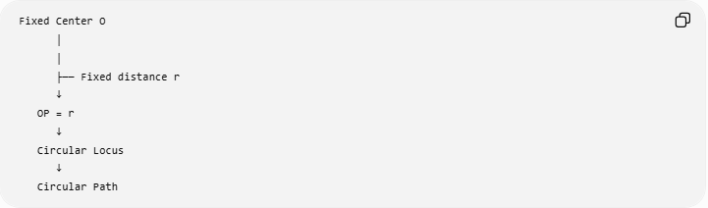
Fixed Center O
│
│
├── Fixed distance r
↓
OP = r
↓
Circular Locus
↓
Circular Path

Circular Path and Curvature
# Source: AI Source: Provided by: [Data Path: Persons Table -> ID Column: 1, Name_En Column: Motasem Essam] -> From: [ChatGPT] on [7/25/2026]
Unlike a straight-line path, a circular path has constant nonzero curvature.
For a circle:
$$\boxed{κ=\frac{1}{r}}$$
where $r$is the radius.
Therefore:
- larger radius → smaller curvature,
- smaller radius → larger curvature.
Example
For:
$$r=5,$$
the curvature is:
$$\boxed{κ=\frac{1}{5}}.$$

Circular Path and Tangent Direction
# Source: AI Source: Provided by: [Data Path: Persons Table -> ID Column: 1, Name_En Column: Motasem Essam] -> From: [ChatGPT] on [7/25/2026]
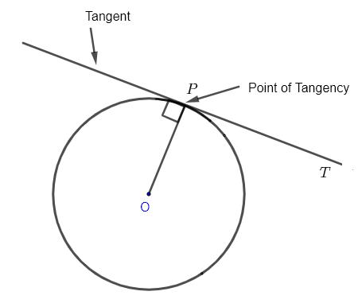
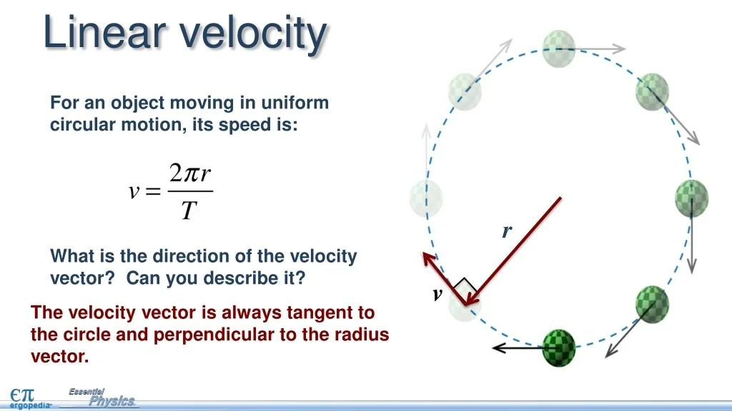
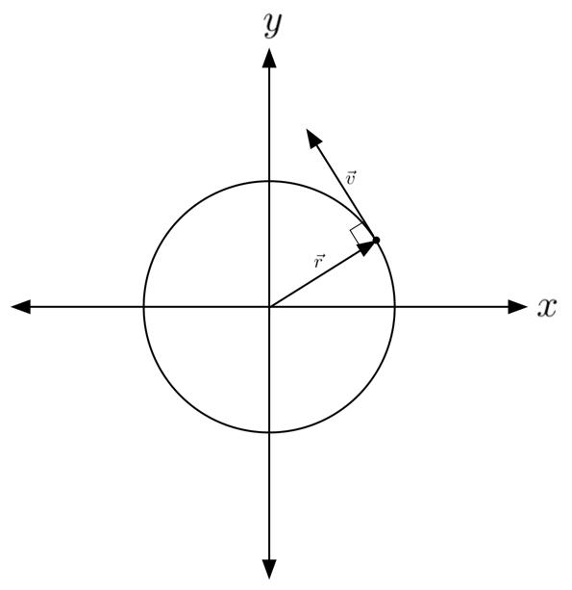
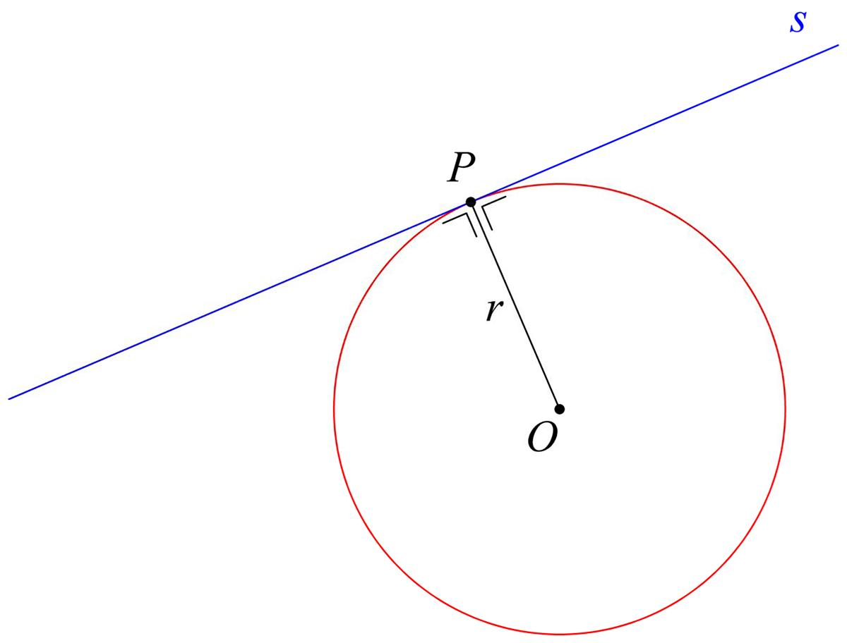
At any point $P$on a circular path, the tangent is perpendicular to the radius:
$$\boxed{OP⊥\text{tangent at }P}$$
Therefore, if a point is moving along a circular path, its instantaneous direction of motion is tangent to the circle.

Circular Path and Angular Position
# Source: AI Source: Provided by: [Data Path: Persons Table -> ID Column: 1, Name_En Column: Motasem Essam] -> From: [ChatGPT] on [7/25/2026]
The position of a point on a circle can be described using an angle $θ$.
For a circle centered at the origin:
$$\boxed{x=r\cos{θ}} \\ \boxed{y=r\sin{θ}}$$
The angle determines the point's position around the circle.

Circular Path Length
# Source: AI Source: Provided by: [Data Path: Persons Table -> ID Column: 1, Name_En Column: Motasem Essam] -> From: [ChatGPT] on [7/25/2026]
For a full circular path:
$$\boxed{L=2πr}$$
For an arc with angle $θ$in radians:
$$\boxed{L=rθ}$$
For an angle in degrees:
$$\boxed{L=\frac{θ}{{360}^{∘}}\left(2πr\right)}$$
Example
For:
$$r=10, θ={120}^{∘}, \\ L=\frac{120}{360}\left(2π\right)\left(10\right) \\ \boxed{L=\frac{20π}{3}}.$$

Circular Path and Area
# Source: AI Source: Provided by: [Data Path: Persons Table -> ID Column: 1, Name_En Column: Motasem Essam] -> From: [ChatGPT] on [7/25/2026]
The path itself is one-dimensional, but the region enclosed by a full circular path has area:
$$\boxed{A=πr^{2}}.$$
This distinction is important:
$$\boxed{\text{Circle = boundary/path}}$$
while:
$$\boxed{\text{Disk = enclosed region}}$$

Circular Path vs Straight-Line Path
# Source: AI Source: Provided by: [Data Path: Persons Table -> ID Column: 1, Name_En Column: Motasem Essam] -> From: [ChatGPT] on [7/25/2026]
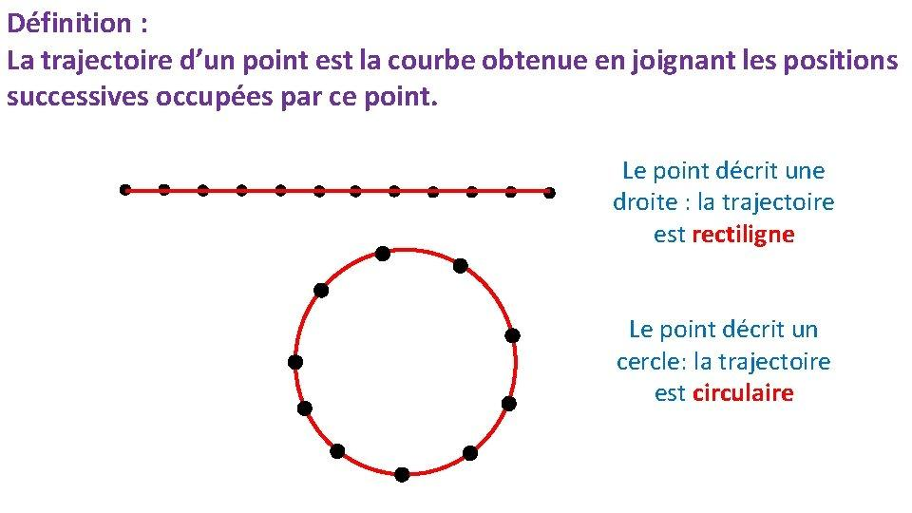
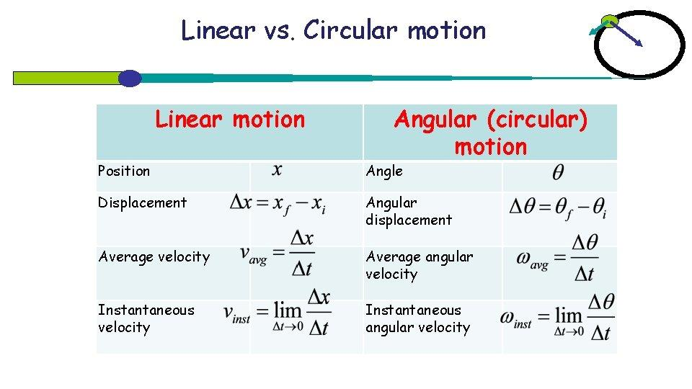
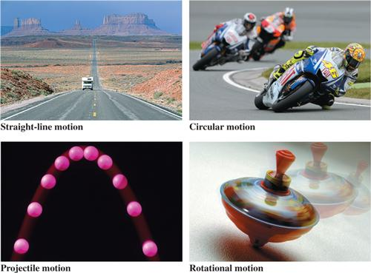
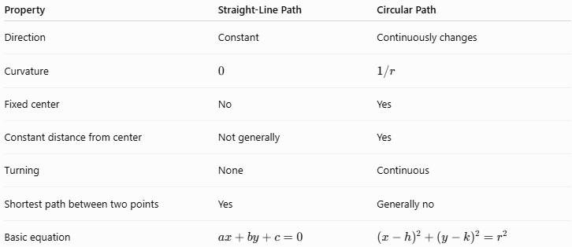
Property | Straight-Line Path | Circular Path
Direction | Constant | Continuously changes
Curvature | $$0$$ | $$1/r$$
Fixed center | No | Yes
Constant distance from center | Not generally | Yes
Turning | None | Continuous
Shortest path between two points | Yes | Generally no
Basic equation | $$ax+by+c=0$$ | $${\left(x-h\right)}^{2}+{\left(y-k\right)}^{2}=r^{2}$$

Classification Summary
# Source: AI Source: Provided by: [Data Path: Persons Table -> ID Column: 1, Name_En Column: Motasem Essam] -> From: [ChatGPT] on [7/25/2026]

Circular Path
│
├── By Extent
│ ├── Full Circle
│ ├── Circular Arc
│ ├── Semicircle
│ └── Quarter Circle
│
├── By Arc Size
│ ├── Minor Arc
│ └── Major Arc
│
├── By Direction
│ ├── Clockwise
│ └── Counterclockwise
│
├── By Motion
│ ├── Uniform
│ └── Non-Uniform
│
├── By Plane
│ ├── Horizontal
│ ├── Vertical
│ └── Inclined
│
├── By Representation
│ ├── Coordinate
│ ├── Parametric
│ └── Vector
│
└── By Structure
├── Restricted
├── Concentric
├── Offset
└── Combined

Key Formulas
# Source: AI Source: Provided by: [Data Path: Persons Table -> ID Column: 1, Name_En Column: Motasem Essam] -> From: [ChatGPT] on [7/25/2026]
Circular-Path Condition
$$\boxed{OP=r}$$
Circle Equation
$$\boxed{{\left(x-h\right)}^{2}+{\left(y-k\right)}^{2}=r^{2}}$$
Circumference
$$\boxed{C=2πr}$$
Arc Length — Radians
$$\boxed{s=rθ}$$
Arc Length — Degrees
$$\boxed{s=\frac{θ}{{360}^{∘}}\left(2πr\right)}$$
Circle Parametric Equation
$$\boxed{x=r\cos{t}, y=r\sin{t}}$$
Circle with Center $\left(h , k\right)$
$$\boxed{x=h+r\cos{t}, y=k+r\sin{t}}$$
Angular Velocity
$$\boxed{ω=\frac{dθ}{dt}}$$
Tangential Speed
$$\boxed{v=rω}$$
Centripetal Acceleration
$$\boxed{a_{c}=\frac{v^{2}}{r}=rω^{2}}$$
Curvature
$$\boxed{κ=\frac{1}{r}}$$

Key Points
# Source: AI Source: Provided by: [Data Path: Persons Table -> ID Column: 1, Name_En Column: Motasem Essam] -> From: [ChatGPT] on [7/25/2026]
- A Circular Path is defined by:
$$\boxed{OP=r}.$$
- The center $O$remains fixed while the moving point $P$maintains a constant distance $r$.
- A complete circular path has:
$${360}^{∘}=2π$$
radians.
- A portion of a circle is a circular arc path.
- A semicircular path has angle ${180}^{∘}$.
- A quarter-circular path has angle ${90}^{∘}$.
- A circular path can be traversed clockwise or counterclockwise.
- Uniform circular motion has constant speed but continuously changing velocity direction.
- The tangent to a circular path is perpendicular to the radius.
- The curvature of a circle is:
$$\boxed{κ=\frac{1}{r}}.$$
- A circular path can be represented using Cartesian, parametric, or vector equations.
- The circumference of a full circular path is:
$$\boxed{2πr}.$$
- A circle is the boundary/path, while the disk is the enclosed two-dimensional region.
- Circular paths are fundamental to loci, coordinate geometry, transformations, rotations, circular motion, constructions, and geometric modeling.

Conclusion
# Source: AI Source: Provided by: [Data Path: Persons Table -> ID Column: 1, Name_En Column: Motasem Essam] -> From: [ChatGPT] on [7/25/2026]
A Circular Path is a geometric path generated when a point maintains a constant distance from a fixed center:
$$\boxed{OP=r}.$$
Its principal forms include:
$$\boxed{\text{Full Circle, Arc, Semicircle, Quarter Circle, Minor Arc, Major Arc}}$$
and it can be described using:
$$\boxed{{\left(x-h\right)}^{2}+{\left(y-k\right)}^{2}=r^{2}}$$
or parametrically by:
$$\boxed{x=h+r\cos{t}, y=k+r\sin{t}}.$$
Unlike a straight-line path, a circular path continuously changes direction and has constant curvature:
$$\boxed{κ=\frac{1}{r}}.$$
Circular paths therefore form one of the most important classes of geometric paths and provide the foundation for circles, arcs, circular motion, rotational geometry, loci, and many geometric constructions.

